SURVEY ON MARKET COUPLING GATE CLOSURE TIME
IN CZ-SK-HU & PL-RO DAY-AHEAD MARKETS

Dear Market Participant,

The CZ-SK-HU Market Coupling has proven its benefits since its launch 11 September 2012. In order to provide benefits of implicit allocation to its market participants Romania and Poland expressed their interest in joining the current CZ-SK-HU MC (press release from 30 January 2013). All affected parties since then have been analyzing possibilities to extend the CZ-SK-HU MC towards these two countries while benefiting maximally from the integration.
The most valuable and acceptable approach is considered and fundamental decisions has to be made. Currently the key point is discussed related primarily to an arrangement of capacity allocation on the common borders of the Czech Republic, Slovakia, Hungary, Poland and Romania with respect to anticipated implementation of implicit auctions (i.e. market coupling): Gate Closure Time (GCT) of the markets involved in the future coupling. As all players on all involved markets may be affected by this parameter, the CZ-SK-HU-PL-RO TSOs and PXs (hereinafter Parties) kindly ask for feedback on this topic. Based on the result of the survey the final decision will be made by the relevant regulator authority of each country.
In the abovementioned context and also having in mind that initiatives focused on Market Coupling in the CEE region face many challenges (especially related to development of the Flow Based capacity calculation method and unplanned flows issue), Agency for Cooperation of Energy Regulators (ACER) and National Regulatory Authorities (NRAs) suggested unofficially (as Joint Declaration has not been withdrawn) to benefit from the current connection of Polish day-ahead electricity market to the future NWE region via the Swe-Pol DC cable. The idea of ACER and the NRAs is to connect the extended CZ-SK-HU MC with the Polish and Romanian markets to CWE/NWE markets using the Swe-Pol DC cable. This would have the following implications:
- GCT would be set to 12h00 CET in all interconnected day-ahead markets: 5M and CWE/NWE (PL-SE, PL-CZ, PL-SK, CZ-SK, SK-HU, HU-RO);
- The 5M MC would be coupled to the NWE region (FR, DE, BE, NL, DK, NO, SE, FI, etc.) with the only one interconnector: the Swe-Pol DC cable;
- Explicit daily capacity auctions organized by CAO GmbH would be still performed at CZ-DE, CZ-AT, HU-AT and PL-DE profiles (with the same timing as today, i.e. GCT at 09h15 CET, results at 09h25 or 10h15 CET at the latest).
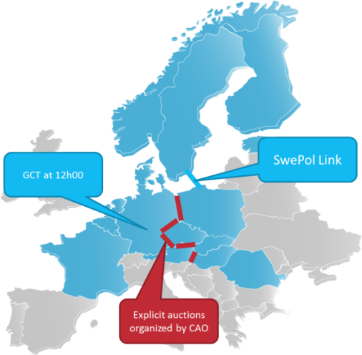
We understand that proposed arrangement of capacity allocation and day-ahead markets can influence the market participants and their way of the trading.
This extension of CZ-SK-HU MC is planned as an interim step towards the creation of the European Internal Electricity Market (i.e. inclusion of all borders within CEE region). The decision with this regard is going to be made in favor of market participants therefore we are interested in receiving your valuable opinion. It will considerably help TSOs, PXs and NRAs to plan the way forward towards the European Internal Electricity Market in the most efficient way.
Please answer the following question:
Do you have any objection to the solution where both the NWE region and five markets are coupled via Swe-Pol link and there will be one unique GCT set to 12h00 CET? At the same time on some borders between them the transmission capacity will be (for transitional period of time) still allocated via explicit auctions organized by CAO GmbH?
- We do not have any objection against 12h00 CET.
- Shifting GCT to 12h00 CET is not acceptable for us until implicit auction is introduced on all CEE borders. This means coupling with Polish day-ahead market will not be implemented before introduction of implicit auction on all CEE borders.
If it is not acceptable for you, would you please indicate what your major concerns are?

We all would like to thank you very much in advance for your valuable input to this issue. Your position will be taken into consideration by the final decision.

HOW TO ANSWER TO THE SURVEY

The answers on the survey are welcome till 24 July 2013 via the Answer Template below to konzultace@eru.cz

If you have any question, please, do not hesitate to contact us:

Our contact persons are:

Company | Contact person | Email address for questions
URE | Jakub Paluch | jakub.paluch@ure.gov.pl
PSE | Jacek Ratz | jacek.ratz@pse.pl
TGE | Jacek Brandt | jacek.brandt@tge.pl
ERÚ | Vojtěch Jahoda | vojtech.jahoda@eru.cz
CEPS | Martin Palkovsky | palkovsky@ceps.cz
OTE | Ondřej Máca | omaca@ote-cr.cz
URSO | Nataša Hudcovičová | hudcovicova@urso.gov.sk
SEPS | Mário Turčík | mario.turcik@sepsas.sk
OKTE | Juraj Šedivý | juraj.sedivy@okte.sk
MEKH | Attila Bakonyi | bakonyia@mekh.hu
MAVIR | Réka Sárközi | sarkozir@mavir.hu
HUPX | Gábor Katona | katona@hupx.hu
ANRE | Lusine Caracasian | lcaracasian@anre.ro
Transelectrica | George Visan | george.visan@transelectrica.ro
OPCOM | Cristina Setran | cristina.setran@opcom.ro

ANSWER
FOR THE SURVEY ON
MARKET COUPLING GATE CLOSURE TIME
IN CZ-SK-HU & PL-RO DAY-AHEAD MARKETS

Please fill in and send back till 24 July 2013 to konzultace@eru.cz

Company name:
Contact person name:
Contact person e-mail:
Market activity: | ◻ PL | ◻ CZ | ◻ SK |  | ◻ HU | ◻ RO
Do you have any objections to the solution where both the NWE region and five markets are coupled via Swe-Pol link and there will be one unique GCT set to 12h00 CET? At the same time on some borders between them the transmission capacity will be (for transitional period of time) still allocated via explicit auctions organized by CAO GmbH? | ◻ We do not have any objection  against 12h00 CET. |  |  | ◻ Shifting GCT to 12h00 CET is  not acceptable for us until implicit  auction is introduced on all CEE  borders. This means coupling with  Polish day-ahead market will not  be implemented before introduction  of implicit auction on all CEE  borders.
If it is not acceptable for you, would you please indicate what your major concerns are? | Our concerns are:

Deadline for submitting bids into PX’s order book.
http://www.acer.europa.eu/Electricity/Regional_initiatives/Meetings/27th_CEE_IG_meeting/Document Library/1/CEE NRAs joint declaration_20120326.pdf
CET/CEST

