Description of the functionality of the Day-ahead market trading system in the transitional period – after the installation of 4M MC functions

This document summarizes the changes of the electricity Day-ahead Market trading system resulting from implementation of 4M MC solution. These two milestones are important from market participant point of view:

- Installation of 4M MC solution in the production environment - scheduled on 4. 11. 2014. (It will be done within a standard night shutdown of the CS OTE system – taking effect on 5. 11. 2014)
- Activation of 4M MC solution – scheduled on 19. 11. 2014 (for delivery day 20. 11. 2014)

The transitional period will be between these days: 4.11. 2014 - 19.11.2014. Detailed information about this period is stated below. During the transitional period the trading system will operate in line with principles of the current solution 3M MC and therefore it will not be possible to submit new types of block bids. This is also valid for delivery days which belong to the period after the activation of 4M MC solution i. e. after 20.11.2014.

Description of the changes is structured in terms of:
- visual changes on the web
- changes in the interface of automatic communication
- operation of the system in terms of standard and new block bids

After installation of 4M MC solution - 4M MC solution is still inactive in the transitional period 4.11.2014 -19.11.2014

- Visual changes on the OTE web after the installation of 4M MC solution

- Trading screen:
  - On the trading screen it is no longer possible to optionally display inactive bids because the panel has been modified (see the original panel Bids for delivery day in the 3M MC solution). The inactive bids can be viewed only in the report Bids by delivery day:

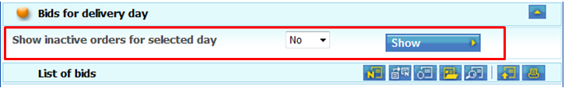

  - New icons for handling of new type of bids are already visible in panel List of bids (chapter 2.3.2 - user manual of Day-ahead market). It is not possible to use these new icons in the transitional period (create, modify block bid, or create/remove link). New icons are either non-functional or displayed in the original form.

4M MC solution the visual aspect of panel List of bids:

  - Forms for submission/modification/cancellation of bids on the Day-ahead market remains the same as for the current 3M MC solution until the day of 4M MC solution activation. Including the functionality of the Total block 1acceptance for a bid for sell.

New functionality which allows submission of more bids for sell/buy for one participant and one delivery day is not active.

Bid submission – sell: functionality – Total block 1 acceptance is active
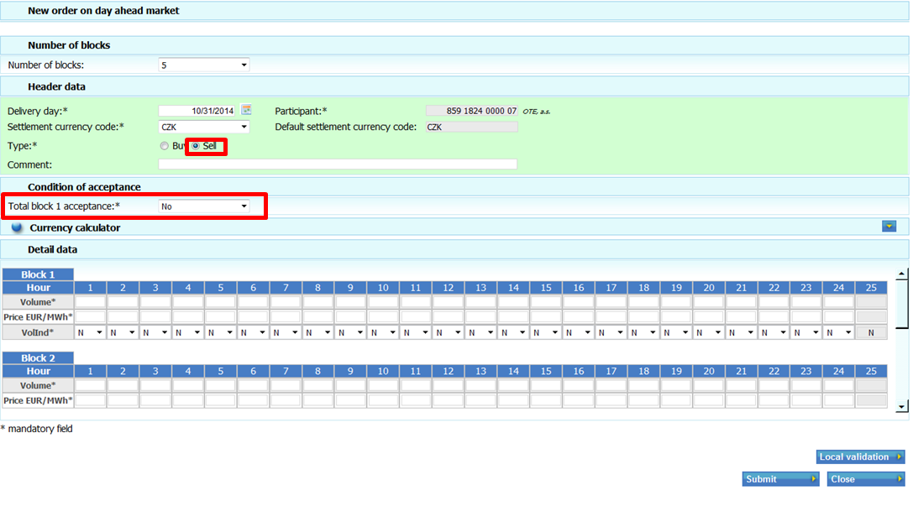
Bid submission – buy: function - Total block 1 acceptance is inactive
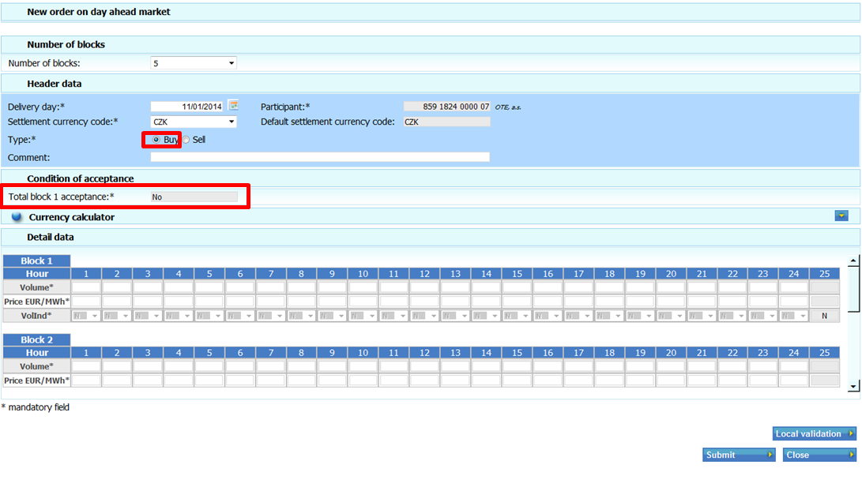

- Menu – Reports:
  - Menu Reports – DM has been already modified:
    - contains a new report – Linked profile block orders by delivery day (it doesn´t contain any data as it is still not possible to submit profile block orders and link them)
    - the report History by market participant has been removed
    - The order of reports has been changed
  - Current reports have been already modified -> contain new columns which are without data because it is still not possible to submit new types of bids – e.g. the report Bids by delivery date contains columns Category, Parent Block Order ID, Exclusive Group

- Changes in the interface of automatic communication after installation of 4M MC solution

- Interface of AC will be extended by new elements after deployment:
  - Category: categories of block bids (PBO/FHO),
  - AcceptRatio: minimum ratio of matched volume ( now only value 100),
  - ParentBlock: ID of parent bid
  - ExclsGroup: identification of exclusive group

It is possible to use new elements for AC/Upload, they will pass successfully the check of XML structure (they are valid) but they will be ignored in the processing of the bid. Bid with new elements will be placed as a standard bid (only elements which are valid for 3M MC will be used)
New types of bids (PBO/FHO) will not be accepted just as it is not possible to place new types of bids via web interface.

- New types of bids cannot be submitted in the transitional period neither via web form nor via interface of automatic communication. Only current types of bids can be submitted.

- Original rules are valid for creation of standard spot bids
  - Only one bid for buy and one bid for sell for 1 participant and delivery day
  - It is possible to submit Total block 1 acceptance for bid for sale
  - If the participant setting allows the stock exchange to submit bids for participant, the stock exchange can submit, modify or cancel spot bids instead of participant – the same rules apply as described above.

ATTENTION! The rules for submission of standard spot bids are also valid in case participant will enter bid for delivery day which already belongs to the period after the activation of 4M MC solution!!!

