User Manual

of Information System



**D1.4 CS OTE external interface**

Part D1.4.X CDSDATA and Markets and Clearing Communication Format for the 15 Minute Clearing Period

This document and its content are confidential. It is forbidden to reproduce the document or its parts, to show it to third parties or to use it for any other purposes than it was provided without prior written agreement by OTE, a.s.

|  |  |
| --- | --- |
| Date | Description of the change |
| 29. 05. 2020 | Basic description of changes for CDSDATA 15 min |
| 05. 06. 2020 | Basic description of changes for the 15-minute accounting period in the ISOTEDATA and RESPONSE reports |
| 10. 06. 2020 | Formal corrections |
| 12. 06. 2020 | Added chapter 3.4 General CDSDATA recommendations |
| 16. 06. 2020 | Addition to the MAW unit comment |
| 30. 06. 2020 | Merger of documents for CDSDATA and Markets and settlements, change of chapter numbering |
| 03. 07. 2020 | Revision and addition of parts of the schedule |
| 08. 07. 2020 | Completion of answers to participants' questions |
| 31.03.2022 | Addition of impact to the communication format RESDATA and CDSDATA, updating the schedule |
| 11.4.2022 | Update of the high-level schedule in chapter 2.2. and chapter 6.1. |
| 01.08. 2022 | Document update caused by technical and functional modifications |
| 09. 11. 2022 | Document update in chapter 4. 1. 1. and 4.1.5. |
| 01.03.2023 | Chapter 2 update |
| 13.4.2023 | English version |
| 5.6.2023 | English version of market related areas |

**Content**

1 Introduction 5

2 Schedule of implementation and transition tests for 15 min. settlement period 7

2.1 Legislative requirements 7

2.2 Schedule of modifications to the interface of GoLive sub-parts for the transition to 15 min. settlement period 8

2.3 Procedures during the transition to the 15-minute billing period 9

3 CDSDATA Area 11

3.1 Description of changes in the current CDSDATA format: 11

**3.1.1** **Changes in the element „Data“** 11

**3.1.2** **Changes in the „Location“ element** 12

**3.1.3** **Example of changes to the CDSDATA message** 12

**3.1.4** **Examples in XML format** 13

3.2 Effects of changes to code lists 14

**3.2.1** **Role of profiles** 14

**3.2.2** **Time period resolution – Resolution attribute** 15

**3.2.3** **CDSDATA format message codes – Message-code attribute** 15

3.3 General recommendations for CDSDATA 16

**3.3.1** **Writing time series over a longer period** 16

**3.3.2** **Aggregated data submission** 17

**3.3.3** **Data sending times** 17

**3.3.4** **Provision od data** 18

4 Trading and Settlement 19

4.1 Description of Impacts According to Individual Agendas 19

**4.1.1** **Day ahead Market (DaM)** 19

**4.1.2** **Intraday Auctions (IDA)** 20

**4.1.3** **Intraday Market (IM)** 20

**4.1.4** **Settlement** 20

**4.1.5** **Registration of Realization Diagrams (RRD)** 21

4.2 Description of Format Changes 22

**4.2.1** **Description of Format Changes within ISOTEDATA** 22

**4.2.2** **Description of Format Changes within ISOTEREQ** 27

**4.2.3** **Description of Format Changes within RESPONSE** 29

4.3 Impact of changes to code lists 32

**4.3.1** **Codes for Unit Types – attribute Unit** 32

**4.3.2** **Profile Role – attribute Profile-role** 32

**4.3.3** **Time Unit Resolution – attribute Resolution** 33

**4.3.4** **List of Message Codes – attribute message-code** 33

**4.3.5** **Other Code Lists** 35

5 RESDATA Area 36

5.1 Description of changes in the existing RESDATA format 36

**5.1.1** **Changes in "ProfileData" element** 36

**5.1.2** **Changes in the “Profile” element** 37

**5.1.3** **Example of changes to the RESDATA message** 37

5.2 Impact of changes to code lists 38

**5.2.1** **Profile value types** 38

**5.2.2** **Time period resolution – Resolution attribute** 39

**5.2.3** **RESDATA format message codes – atribut Message-code** 39

6 Settlement of comments from market participants from the webinar (ERÚ, OTE, representatives of traders and TSO/ DSO/LDSO) 18/06/2020 40

6.1 Answers to questions raised during the webinar on 6/18/2020 40

# Introduction

This document describes changes in the communication format of CDSDATA and changes in the communication format of AK reports in the area of trading agendas, settlement and registration of execution diagrams related to the transition to a 15-minute settlement period.

The presented information reflects the currently known developments on the market (especially legislative) as of March 2023 and with knowledge of the information valid on that date. The market operator cannot rule out at the moment that the schedule or the expected changes to the message formats will undergo changes, not only as a result of the development of the European electricity market.

Other further changes in CS OTE, such as IP addresses and other possible technical information, will be published only in early 2024, when we know more from the UAT and E2E test processes as well.

**CDSDATA area**

The existing CDSDATA message format is used for sending data in a granularity of 60 minutes. Newly, this format will be used for sending data to CS OTE/retrieving data from CS OTE in a granularity of 15 minutes or 60 minutes.

In connection with shortening the length of the period, there will be an increase in the number of communicated values of continuous measurement data, and without adjustments there would be a 4-fold increase in the physical size of the messages. For this reason, the existing format was modified and optimized in such a way as to reduce the data intensity and thus the volume of data transferred between individual market participants. The proposed changes will reduce the increase in the physical size of messages to two times, including an increase in the number of decimal places of data transmitted.

In addition to its own message format, this document also contains a proposal for other measures and rules for sending large volumes of data so that the entire communication scenario is as optimal as possible.

**RESDATA area**

The existing RESDATA message format is currently used for sending data in a granularity of 60 min. as required by legislation, especially Act No. 165/2012 Coll. and Decree No. 408/2015 Coll., on Electricity Market Rules. However, this may change. Newly, this format will be used for sending/receiving data within CS OTE in a granularity of 15 minutes or 60 minutes. The format of the RESDATA report was historically derived from the CDSDATA format, for which an optimization adjustment has already been proposed in connection with the transition to a 15 min interval. As in the case of CDSDATA, in RESDATA messages, in connection with the shortening of the period length, there would be an increase in the number of communicated values of profile data of the monthly statement, and without adjustments there would be a 4-fold increase in the physical size of the messages. For this reason, the existing RESDATA format will also be modified and optimized in such a way as to reduce the data intensity and thus the volume of data transferred between external participants and CS OTE. The proposed changes will reduce the increase in the physical size of messages to two times, including an increase in the number of decimal places of data sent.

**Markets and Clearing Area**

Existing message formats are used for sending data in a granularity of 60 min. It will now be possible to use the formats for sending/receiving data to/from CS OTE in a granularity of 15 minutes or 60 minutes.

In connection with the shortening of the period length, there will be an increase in the number of communicated values at the time series level, and therefore in some cases optimizations were made in order to reduce the data intensity and thus the volume of transmitted data.

# Schedule of implementation and transition tests for 15 min. settlement period

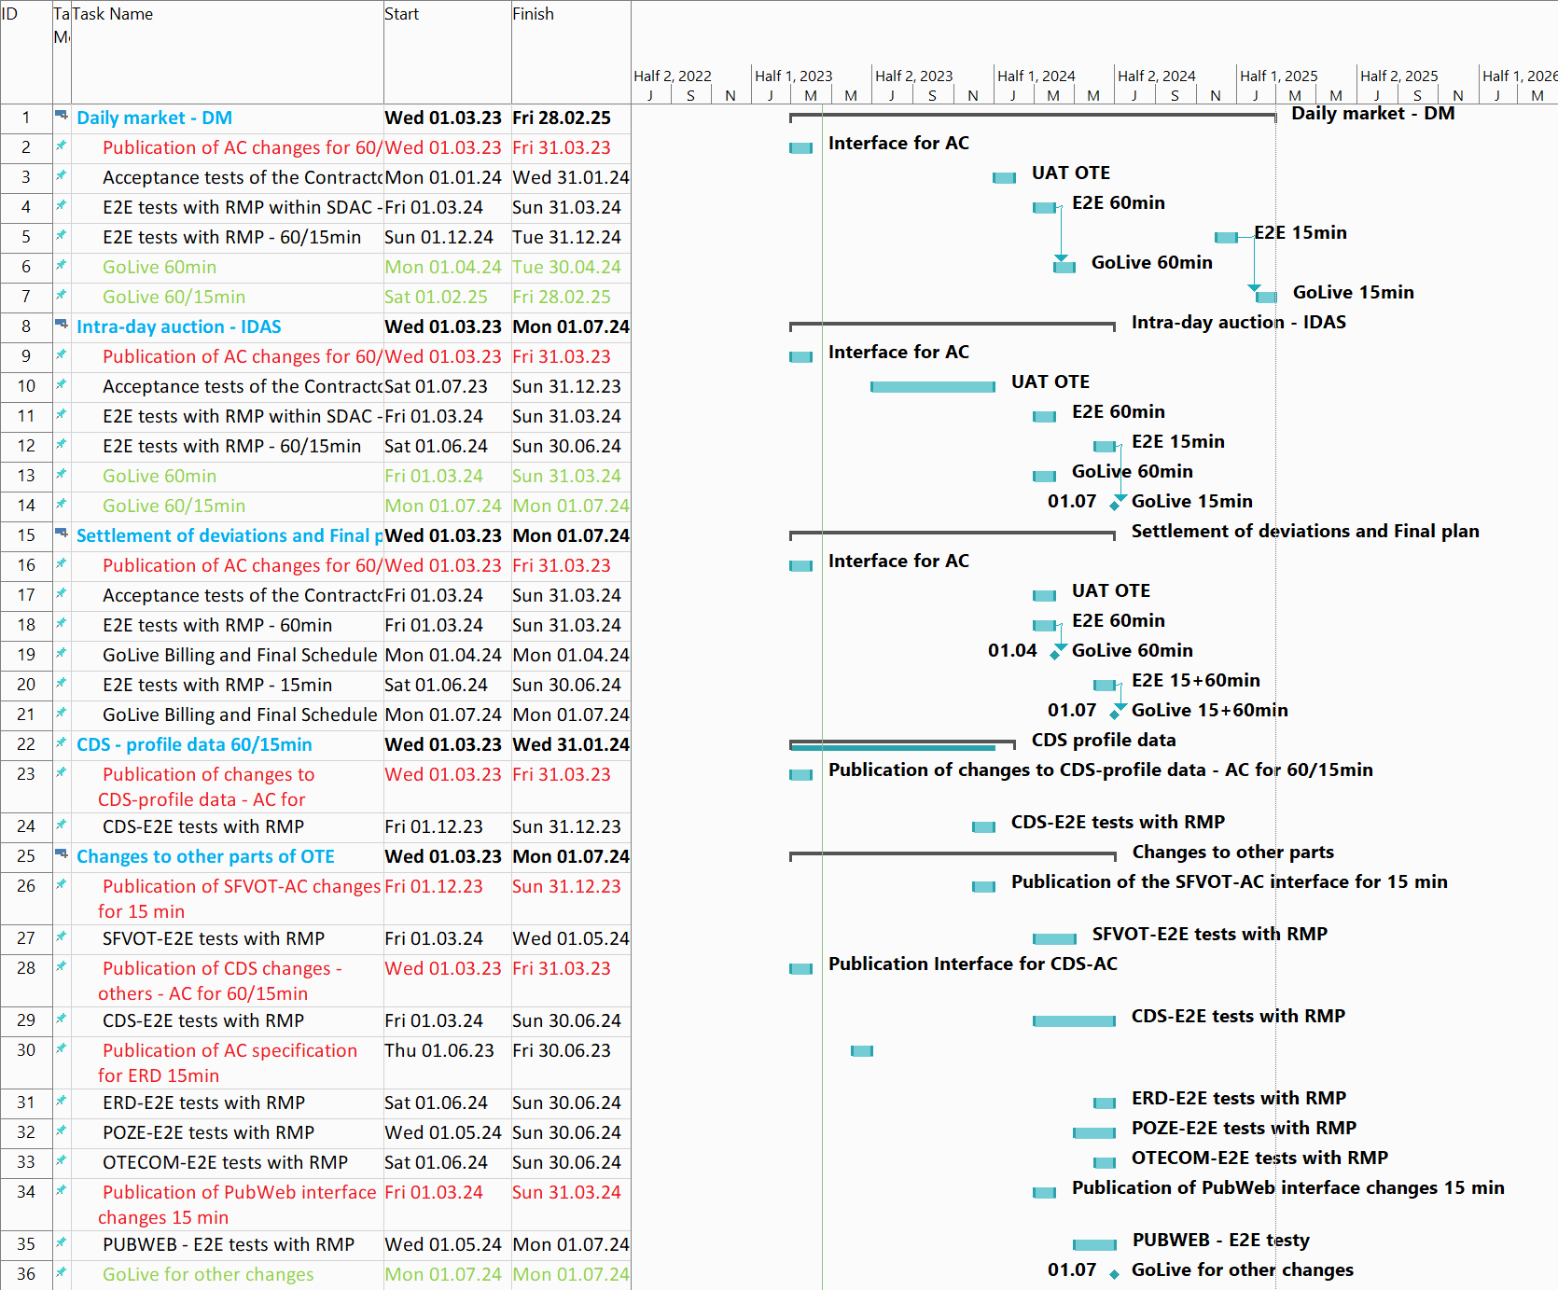

## Legislative requirements

* **Commission Regulation (EU) 2017/2195** establishing a framework instruction for the commercial provision of power balancing in the electricity industry - the obligation (Article 53) to implement a 15-minute discrepancy settlement interval within three years of the entry into force of the regulation
* **ERÚ’s decision of 29/06/2018** to grant an exception (derogation) from this requirement, but no later than 1/1/2025
* **Regulation (EU) 2019/943 of the European Parliament** and of the Council on the internal electricity market - Article 8(4). From 1 January 2021, the deviation settlement interval is 15 minutes in all planning areas, unless the regulatory authorities grant a general or individual exemption. General exemptions can only be granted until 31 December 2024.
* The amendment to **the Measurement Ordinance foresees** the start of sending measurements in 15-minute granularity on 7/1/2024
* As part of the discussion led by ERÚ, it was decided **that the date of transition to a 15-minute settlement period in the Czech Republic will be July 1, 2024**

## Schedule of modifications to the interface of GoLive sub-parts for the transition to 15 min. settlement period

Description of modifications in external interfaces for automatic communication due to the transition to 15 min. the settlement interval is given in more detail in the separate document "*D1.4.4__Format_messages_XML*", which describes the adjustments for deployment in Q1/2024 (publication stage I). Additional changes to the interface that will go live from 1/7/2024 (release stage II) will be published in this XML message format document according to the schedule below:

|  |  |  |  |
| --- | --- | --- | --- |
| Step | Term from | Term to | Link to description |
| 1. **A. External Change Interface - Disclosure I** |  |  |  |
| Interface for AK for market areas - DT, IDAs, ZO - universal interface for 15/60 minutes |  | 31.3.2023 | DM - Chapter 3. Daily market  IDA - Chapter 4. Intraday Auction (IDA)  ImS - Chapter 5. Settlement - ZT and ImS |
| Interface for AK for the FS area - an extension for the IDAs market |  | 31.3.2023 | Chapter 6. FS |
| Interface for AK for the area of measured profile data in CDS (CS DATA universal for 15/60min) |  | 31.3.2023 | Chapter 7. CDS |
| 1. **External interface and other changes - disclosure II** |  |  |  |
| Interface for AK for area in CDS (impacts on other reports for 15min) |  | Q2-3/2023 | The document "D1.4.4_CZ_Format_messages_XML" will be updated |
| Interface for AK for FS areas - impacts 15min |  | 31.12.2023 | The document "D1.4.4_CZ_ Format_messages_XML" will be updated |
| Rozhraní pro AK pro oblast RRD – dopady 15min |  | 30.6.2023 | The document "D1.4.4_CZ_ Format_messages_XML" will be updated |
| Interface for the PubWeb area - impacts 15 min |  | 31.3.2024 | The document "D1.4.4_CZ_ Format_messages_XML" will be updated |
| Changes in the technical infrastructure of CS OTE (IP addresses, links...) |  | Q1-Q2/2024 | It will be in a separate document |
| 1. **CDS** |  |  |  |
| GoLive CDS interface – universal interface for CS DATA profile data for 15/60 minutes, see Block A |  | 31. 1. 2024 |  |
| 1. **DM, IDAS, ImS** |  |  |  |
| GoLive modules with a universal interface for 15/60 min, see Block A. |  | 30. 4. 2024 |  |
| 1. **ImS, RRD, IM, CDS, SFVOT, PubWeb** |  |  |  |
| GoLive modules with a modified interface for only 15 minutes, see Block B. |  | 1.7.2024 |  |

## Procedures during the transition to the 15-minute billing period

**Principles of measurement data transfer:**

* **Day D = 1st day of deviation evaluation in the 15-minute settlement interval (1.7.2024)**
* Data for evaluation intervals prior to D-Day will be sent at a granularity of 1h with a resolution to whole kWh.
* Data for evaluation intervals from D-day onwards shall be sent at a granularity of 15 min with a resolution of 0,01 kWh.
* 15-minute profiles will be prepared in the OTE CDS for day D.
* Receipt of corrected metering values for pre-D-Day data will be at a granularity of 1h per whole kWh. This is because if data is sent back at a granularity of 15 min, there may be a loss of resolution in the calculation of MV and ZMV deviations.
* The report with a description of the measurement data of each PDT will be sent to market participants in the same granularity as the measurement data report received in CS OTE (see above), i.e. in the format in which the deviations are calculated.
* The existing messages (121, 122 and 131) for query and response to query profile data over a 1 hour period will be retained - the granularity of the data will be determined by the resolution attribute.
* Messages with identical message codes (121, 122 and 131) will be used for sending measurement data, data descriptions, queries to profile measurement data within a 15 minute period - data granularity will be determined by the resolution attribute.

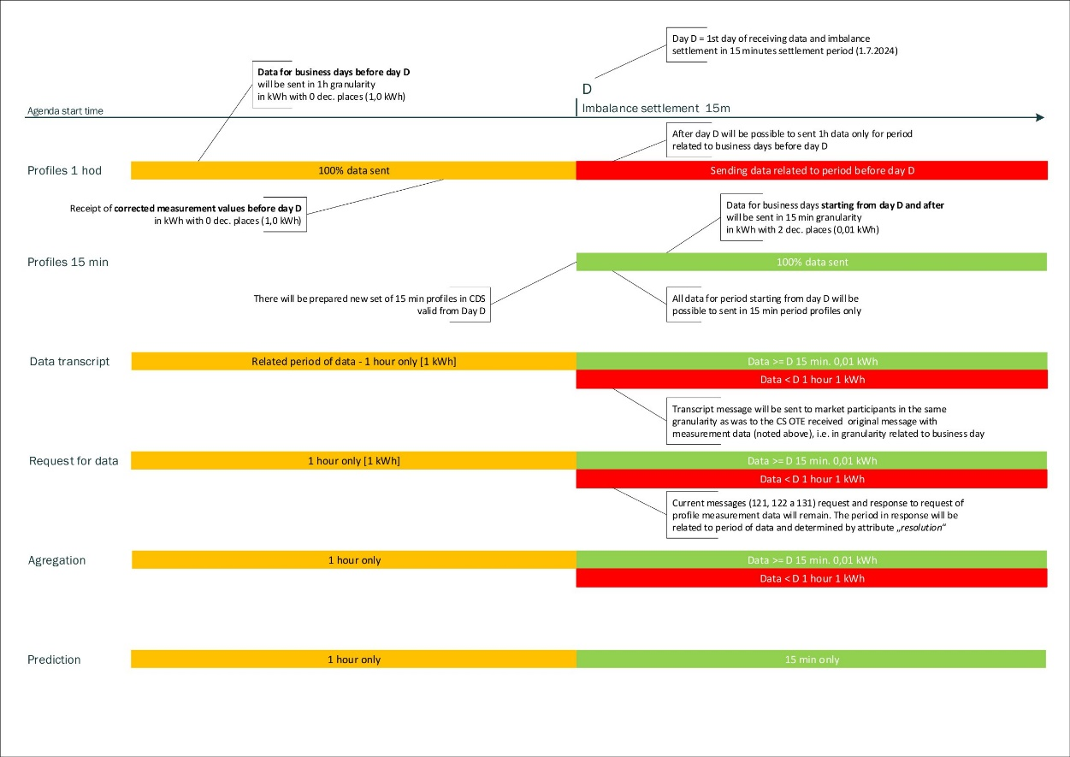

**Starting on D-x (to be specified), it will be possible to receive contract values on delivery day D and at a granularity of 15 minutes.**

* Calculation and settlement of deviations
  + DV calculated on day D for day D-1 at a granularity of 1h
  + DV calculated on day D+1 for day D at a granularity of 15 min
  + MV and ZMV calculated for the period before D-day at a granularity of 1h
  + MV and ZMV calculated for the period from D-day onwards will be performed at a granularity of 15 min

*Note: DV-* *daily evaluation of deviations, MV – monthly evaluation of deviations,   
ZMV – final monthly evaluation of deviations*

# CDSDATA Area

## Description of changes in the current CDSDATA format:

From the point of view of changes, in the „Location“ part are the child segments containing measured data, which are in the „Data“ part. The element „Location” contains the identification of the type of data being sent, and the „Data“ element then contains the data itself.

Items to be deleted (or items moved to another level) are visually represented with red crossed-out text, while new items (or moved from another level) are highlighted with green shading. These structural changes are described in more detail together with content changes in the following subsections.

### **Changes in the element „Data“**

The element data contains following attributes, the individual changes are listed in the table below.

|  |  |  |
| --- | --- | --- |
| **Attribute** | **Description** | **Marked changes** |
| **date-time-from** | Beginning of the measurement period | The time is now given in 15-minute intervals. |
| ~~date-time-to~~ | End of measurement period | Newly, the attribute is not entered in the Data element. |
| **qty** | Quantity | Change in number of decimal places. Newly, for example, the consumption value of continuous measurement will be given in kWh with accuracy to two decimal places. |
| ~~unit~~ | Unit | Newly, the attribute is not specified in the element Data. The „Unit“ attribute is moved to the element „Location“. |
| **status** | Status of the value | Status of the value is not reported in the message, if it is a valid value. |

Table 1 Changes in the Data element

Ukázka nové podoby elementu „Data“ (včetně jiného statusu hodnoty):

<Data date-time-from="2020-05-13T**00:00:00**" qty="-458**.75**"/>

<Data date-time-from="2020-05-13T**00:15:00**" qty="-457**.70**"/>

<Data date-time-from="2020-05-13T**00:30:00**" qty="-499**.00**" **status="99"** />

<Data date-time-from="2020-05-13T**00:45:00**" qty="-430**.10**"/>

### **Changes in the „Location“ element**

The existing attributes in the „Location“ element are unchanged. The following attributes listed in the table have been added to the element „Location“..

|  |  |  |
| --- | --- | --- |
| **Attribute** | **Description** | **Marked changes** |
| unit | Unit | The „Unit“ attribute has been moved from the „Data“ element. Contains the init related to the quantity in the „Data“ elements. |
| resolution | Period resolution | Period resolution New attribute that determines the length of the period ("PT15M“ – 15 min period, „PT60M“ – 60 min period) |

Table 2 Changes in the Location element

Example of the new look of the element „Location“

<Location id="859182400000000001" profile-role="A12" **unit="KWH" resolution="PT15M"**>

### **Example of changes to the CDSDATA message**

<CDSDATA xmlns="http://www.ote-cr.cz/schema/cds/data" xmlns:xsd="http://www.w3.org/2001/XMLSchema" xmlns:xsi="http://www.w3.org/2001/XMLSchema-instance" answer-required="1" date-time="2020-05-22T05:29:03" dtd-release="1" dtd-version="1" id="M1500000000000000001" message-code="121" time-offset="2">

<SenderIdentification coding-scheme="14" id="8591820000000" />

<ReceiverIdentification coding-scheme="14" id="8591824000007" />

<Location id="859182400000000001" profile-role="A12" **unit="KWH" resolution="PT15M"**>

<Data date-time-from="2020-05-13T00:00:00" qty="-7**.25**"/>

<Data date-time-from="2020-05-13T00:15:00" qty="-8**.30**"/>

<Data date-time-from="2020-05-13T00:30:00" qty="-9**.25**"/>

<Data date-time-from="2020-05-13T00:45:00" qty="-8**.25**"/>

<Data date-time-from="2020-05-13T01:00:00" qty="-10**.40**" **status="99"**/>

<Data date-time-from="2020-05-13T01:15:00" qty="-11**.25**"/>

<Data date-time-from="2020-05-13T01:30:00" qty="-9**.25**"/>

…

…

…

<Data date-time-from="2020-05-13T23:00:00" qty="-8**.25**"/>

<Data date-time-from="2020-05-13T23:15:00" qty="-9**.75**"/>

<Data date-time-from="2020-05-13T23:30:00" qty="-11**.20**"/>

<Data date-time-from="2020-05-13T23:45:00" qty="-13**.80**"/>

</Location>

</CDSDATA>

### **Examples in XML format**

Sample file for 1 day data with a period of 15 min.



Sample file for 30 days of data with a period of 15 min.



## Effects of changes to code lists

The resolution of the content and granularity of the communicated data will be performed using a combination of the profile role (attribute profile-role) and period resolution (attribute resolution).

### **Role of profiles**

The existing profile role code will be retained.

Data in granularity of 15 minutes and 1 hour will be sent by the same profile role according to the content of the transmitted data.

|  |  |  |
| --- | --- | --- |
| **Role** | **Type** | **Number of roles** |
| Axxx | Metered interval values and aggregated values | 53 |
| Bxxx | Actual values non-interval | 3 |
| Cxxx | Negotiated profile | 16 |
| Exxx | Negotiated diagram | 18 |
| Fxxx | RE energy | 140 |
| Gxxx | RE price | 140 |
| Hxxx | Imbalance | 8 |
| Ixxx | Normalized TDD | 2 |
| Jxxx | Corrected TDD and correction coefficients | 13 |
| Kxxx | Climate conditions | 4 |
| Pxxx | Predictions | 9 |
| Sxxx | Sum of corr. /non-corr. estimations | 144 |
| Txxx  SPxx  SVxx  DPxx  DVxx  PPxx  PVxx  EPxx  EVxx | RE from trading platforms | 296 |

Table 3 Profile roles

For RE profiles from trading platforms (TERRE, MARI, PICASSO, GCC), the meaning of the profiles will change. The profile number will be reduced by discarding the third character of the profile role (period specification) as agreed when implementing RE from the trading platforms. The change has an impact on ČEPS and OTE.

### **Time period resolution – Resolution attribute**

The resolution of the length of the time period will be performed using resolution attribute.

|  |  |
| --- | --- |
| **Resolution** | **Description** |
| PT15M | Period 15 minutes |
| PT60M | Period 60 minutes (for profile data before the day of the billing period change) |

Table 4 Time period resolution

### **CDSDATA format message codes – Message-code attribute**

**Existing message codes** will be used for sending messages with profile data (message-code attribute in the message header of CDSDATA element).

|  |  |
| --- | --- |
| **Message code** | **Message description** |
| 121 | Interval metered data |
| 122 | Non-interval metered data |
| 124 | Activated quantity of regulating energy according to generetion of power: regulating energy, unit price |
| 125 | Annual consumption estimation per PDT |
| 160 | Planned consumption diagrams (PDT type B) |
| 161 | Planned generation or consumption diagrams (PDT type A) or generation diagrams (PDT type B) |
| 162 | Planned values of generation |
| 232 | Activated quantity of regulating energy according to generation of power: regulating energy, unit price |
| 236 | Provided regulating energy positive and negative |
| 238 | Annual consumption estimation per PDT type C |
| 252 | Negotiated diagrams for controlling the imbalance responsibility (for data to 31.12.2009) |
| 266 | Planned values of generation A, B and C |
| 272 | Output data – substitutional (computed) values per PDT with metering type B |
| 303 | Data - consumption estimation for imbalance settlement in period, to which the metered meter reading was sent |
| 313 | Data - Imbalances per PDT of type C consumption calculated within the Clearing process |
| 316 | Values of ORS for calc. of imbalances and clearing |
| 323 | Data - metered values - non-interval |
| 333 | Metered values – calculation per primary supplier of PDT |
| 343 | Metered values – aggregated values per ss |
| 563 | Estimated consumption diagrams of groups of PDT(C) - non-adjusted |
| 603 | History diagrams of correction factor of residual balance DS |
| 613 | Estimated consumption diagrams of groups of PDT(C) - adjusted |
| 623 | Metered data per DS - structured by A, B, C |
| 633 | Aggregated data within the state of emergency |
| 643 | Output data for summary values request per SS divided into A, B a C |
| 653 | Output data for summary values request per SS and grid divided into A, B a C |
| 656 | Proportional aggregated ASC2 profile data by supplier |
| 663 | Data of normal and metered climatic conditions (temperatures) |
| 666 | Data from LP diagrams - output data |
| 669 | Temperature correction coefficient - output data |
| 676 | TDD corrig. on temperature |

Table 5 Value profile message codes

Data request messages will be retained and the data time period will be used to build the data description message based on the period for which the data is being sent. That is, for dates before D-day 60 minutes, for dates from D-day onwards 15 minutes.

## General recommendations for CDSDATA

### **Writing time series over a longer period**

*Description:*

If a time series is sent over a **longer period of time** in one message, always state the „Location“ element only once for the given Role/EAN combination, and state the entire continuous sent time series in the subordinate „Data“ element. In XML, it is e.g. possible to write with repetition of the „Location“ element for each role/EAN and day of measurement. However, the result is very inefficient data processing and writing from an XML perspective.

*Benefit:*

The processing of the report and the subsequent provision of data is optimal. For each "Location" element, data is stored separately for all parties in the communication scenario that process the data. Considering the large increase in data volumes, it is necessary that the data storage is as optimal as possible (ie one time series in the report and one data storage). E.g. processing a message containing 500 OPM/Profile Roles in sub-optimal notation takes minutes. With optimal writing, the storage time can be even less than tens of seconds

### **Aggregated data submission**

*Description:*

For sending **larger volumes of data**, it is advisable to use "aggregated" messages. I.e. messages containing data for multiple OPMs/roles. The reason is the streamlining of communication in sending data and subsequent processing.

*Benefit:*

When aggregated data is sent, the overhead needed to transmit one time series drops, and the subsequent processing of data for all participants in a given communication scenario is also more optimal. As part of the individual sending of data, a large number of connections are created during data reception, but also during their transmission to all affected participants. It is also not possible to optimize application data processing (instead of a smaller number of imports of larger volumes of data, a large number of partial imports are performed without the possibility of optimization). The goal and preference is therefore to achieve the sending of larger volumes of data via aggregated messages (e.g. data for the whole month in one message, not in 30 separate messages for each day), to reduce as much as possible the number of possible repetitive checks (e.g. header and Location element in messages with data sent in bulk for the whole month will be checked only once and not 30 times, if the data were sent in separate messages for every single day, then the data will already be processed), and overall save machine processing time. As part of the transition to a 15-minute billing period, the optimal size of the sent message will be determined with respect to all parties involved in the communication scenario (it is already applied, for example, to output messages in data queries)

### **Data sending times**

*Description:*

When sending data to the Market Operator, the Operator adheres to the principle of priority sending of data for the daily imbalance settlement and RE for the previous day. Corrected data of measurement for other days and other data and messages are sent by the Operators only after 2:00 p.m. on the given day.

*Benefit:*

With the increase in the volume of data sent, it is necessary to prioritize data processing for the daily imbalance settlement in a defined time period. If the daily and other data coincide, the time needed to process the batch could run out, with a negative impact on the daily settlement.

### **Provision od data**

*Description:*

Data sent to CS OTE are automatically forwarded to authorized market participants. Data are sent to market participants via a set communication channel. The sent data, including any version of the imbalance settlement, can be obtained by querying the data. This communication scenario will also be affected by the increase in data for a 15-minute period. The query frequency should take into account the expected data growth in the response.

*Benefit:*

The data query communication scenario should be used as optimally as possible. When this scenario is used excessively, the communication with the market participants is overloaded and other priority communications may be affected negatively.

# Trading and Settlement

## Description of Impacts According to Individual Agendas

### **Day ahead Market (DaM)**

An agenda of Day ahead Market (DaM) keeps existing communication scenarios, whilst some structural changes are expected within existing message formats ISOTEDATA, ISOTREQ and RESPONSE.

The agenda of DaM will undergo changes not only regarding the needs of distinguishing the 15 minute trading interval, but also with respect to the cancellation of some functional restrictions.

The essential functional extension, which will be possible to implement after the interface change, is the possibility of mass entry of offers (like a basket on IM) within one data message.

The communication format of the messages will ensure a possibility of data exchange through a single interface in both 15 minute and 60 minute resolution.

Furthermore, the option to request volume indivisibility of periods at the level of the 1st segment of the standard order will be removed (indivisibility of periods will only be indicated for historical data). This discontinued feature can be replaced by using an indivisible block order.

Some no longer supported options are removed from the message format, which until now were kept only for the purpose of historical data provision, however, with the passage of time, historical data with these options ceased to be available. Discontinued options are:

* Default order flag
* Total acceptance of 1. segment

The messages format is expanded with information about Actual Acceptance Ratio strictly related to profile block orders only.

Portfolio of order types will comprise Standard Orders, Profile Block Orders and Linked Profile Block Orders. At the same time, the possibility of using the hourly flexible orders will cease to be available (hourly flexible orders will be provided within historical data only).

In the case of a request for capacity data, a transition from existing ENTSO-E communication messages to the latest version of CIM format is implemented. The following table provides a summary of current and new versions of individual communication messages.

| **Current Situation** | | **New Situation** | |
| --- | --- | --- | --- |
| **Document** | **Ver** | **Document** | **Ver** |
| StatusRequest | 1.1 | StatusRequest_MarketDocument | 4.0 |
| CapacityDocument - OTE | 3.0 | Capacity_MarketDocument *+ possible extensions according to SDAC FB specific needs* | 8.1 |
| AcknowledgementDocument | 5.0 | Acknowledgement_MarketDocument | 8.1 |

Table 6 Summary overview of current and new versions of individual communication messages related to the capacity data communication scenario

### **Intraday Auctions (IDA)**

IDA (Intra Day Auction) is a new agenda, which will share communication messages with DaM agenda. Comparing to DaM, IDA brings new specifics that enforce some structural additions into the messages. In particular, additional dimension at the level of the delivery day is needed, which distinguishes specific intraday auction for a given delivery day.

Capacity data for IDA will be implemented similarly to DaM through communication messages in CIM format, see section 4.1.1 Day a Head Market. The difference from DaM will be in the form of intraday auction specification for a given delivery day.

### **Intraday Market (IM)**

For the IM agenda, which is available through the OTE-COM electricity application, we currently do not foresee any structural changes in the interface.

### **Settlement**

An agenda of Settlement keeps existing communication scenarios, whilst some structural changes are expected within existing message formats ISOTEDATA, ISOTREQ and RESPONSE:

* to ensure the possibility of data exchange through a single interface in both 15 minute and 60 minute resolution,
* to ensure provision of the imbalance settlement results in the same accuracy as an accuracy of the measurement data (5 decimals in the case of MWh)
* to ensure a more efficient size of data messages.

### **Registration of Realization Diagrams (RRD)**

In the case of realization diagrams registration, a transition from existing ENTSO-E communication messages to the latest version of CIM format will be done. The following table provides a summary of the current and new versions of individual communication messages.

| **Current Situation** | | **New Situation** | |
| --- | --- | --- | --- |
| **Document** | **Ver** | **Document** | **Ver** |
| AcknowledgementDocument | 5.0 | Acknowledgement_MarketDocument | 8.1 |
| ScheduleMessage | 3.1 | Schedule_MarketDocument | 5.2 |
| ConfirmationReport | 3.1 | Confirmation_MarketDocument | 5.3 |
| AnomalyReport | 3.1 | AnomalyReport_MarketDocument | 5.2 |
| StatusRequest | 1.1 | StatusRequest_MarketDocument | 4.0 |

Table 7 Summary overview of the current and new versions of individual communication messages related to the registration of realization diagrams communication scenarios

It can be assumed that the ENTSO-E CIM standard would continue to develop until the introduction of changes related to the transition to a 15 minute settlement period within CS OTE into the production. Therefore, it can be expected, that interface changes proposed here are not final, and by the time of its actual implementation it may experience changes as a response to the development of CIM domain.

## Description of Format Changes

### **Description of Format Changes within ISOTEDATA**

As for format changes, the decisive element is "ISOTEDATA.Trade" with child elements containing time series data, which is element "ISOTEDATA.Trade.ProfileData". The table below illustrates the major structural changes and specifies in which agenda (DaM, IDA or Settlement) the given item of type Element (E) or Attribute (A) is used. Items to be deleted (or items moved to another level) are visually represented with red crossed-out text, new items (or moved into new position from another level) are highlighted with green shading, and already existing but renamed items are marked with blue text. These structural changes are described in more detail together with content changes in the following subsections.

| **Element/Attribute** | | | | | **Type** | **Settl** | **DaM** | **IDA** |
| --- | --- | --- | --- | --- | --- | --- | --- | --- |
| **ISOTEDATA** | | | | | E | x | x | x |
|  | *xmlns* | | | | A | x | x | x |
|  | *id* | | | | A | x | x | x |
|  | *message-code* | | | | A | x | x | x |
|  | *date-time* | | | | A | x | x | x |
|  | *~~dtd-version~~* | | | | ~~A~~ | ~~x~~ | ~~x~~ | ~~-~~ |
|  | *~~dtd-release~~* | | | | ~~A~~ | ~~x~~ | ~~x~~ | ~~-~~ |
|  | *answer-required* | | | | A | x | x | x |
|  | **SenderIdentification** | | | | E | x | x | x |
|  |  | *id* | | | A | x | x | x |
|  |  | *coding-scheme* | | | A | x | x | x |
|  | **ReceiverIdentification** | | | | E | x | x | x |
|  |  | *id* | | | A | x | x | x |
|  |  | *coding-scheme* | | | A | x | x | x |
|  | **~~Reference~~** | | | | ~~E~~ | ~~x~~ | ~~x~~ | ~~x~~ |
|  |  | *~~id~~* | | | ~~A~~ | ~~x~~ | ~~x~~ | ~~-~~ |
|  | **Trade** | | | | E | x | x | x |
|  |  | *~~acceptance~~* | | | ~~A~~ |  | ~~x~~ | ~~x~~ |
|  |  | *~~AcceptRatio~~ accept-ratio* | | | A |  | x | x |
|  |  | *actual-ratio* | | | A |  | x | x |
|  |  | *~~Category~~*  *category* | | | A |  | x | x |
|  |  | *error-code* | | | A |  | x | x |
|  |  | *~~ExclsGroup~~*  *excls-group* | | | A |  | x | x |
|  |  | *external-id* | | | A |  | x | x |
|  |  | *id* | | | A |  | x | x |
|  |  | *market* | | | A |  | x | x |
|  |  | *~~ParentBlock~~*  *parent-block* | | | A |  | x | x |
|  |  | *parent-external-id* | | | A |  | x | x |
|  |  | *replacement* | | | A |  | x | x |
|  |  | *resolution* | | | A | x | x | x |
|  |  | *sett‑curr* | | | A |  | x | x |
|  |  | *source-sys* | | | A |  | x | x |
|  |  | *trade-market-flag* | | | A |  | x | x |
|  |  | *trade-session* | | | A |  | x | x |
|  |  | *trade-state* | | | A |  | x | x |
|  |  | *trade-type* | | | A |  | x | x |
|  |  | *trade-day* | | | A | x | x | x |
|  |  | *trade-flag* | | | A |  | x | x |
|  |  | *~~trade-stage~~*  *trade-state* | | | A |  | x | x |
|  |  | *util-flag* | | | A |  | x | x |
|  |  | *version* | | | A | x | x | x |
|  |  | **TimeData** | | | E |  | x | x |
|  |  |  | *datetime* | | A |  | x | x |
|  |  |  | *datetime-type* | | A |  | x | x |
|  |  | **ProfileData** | | | E | x | x | x |
|  |  |  | *profile-role* | | A | x | x | x |
|  |  |  | *unit* | | A | x | x | x |
|  |  |  | **Data** | | E | x | x | x |
|  |  |  |  | *period* | A | x | x | x |
|  |  |  |  | *value* | A | x | x | x |
|  |  |  |  | *~~unit~~* | ~~A~~ | ~~x~~ | ~~x~~ |  |
|  |  |  |  | *splitting* | A |  | (x)[1] |  |
|  |  | **Comment** | | | E |  | x | x |
|  |  | **Party** | | | E | x | x | x |
|  |  |  | *id* | | A | x | x | x |
|  |  |  | *role* | | A | x | x | x |

Table 8 Summary of ISOTEDATA structural changes and use of the format items within individual agendas

#### Changes in the ISOTEDATA message header

The table provides description of header changes listing only attributes affected by the changes.

|  |  |  |
| --- | --- | --- |
| **Attribute** | **Description** | **Change definition** |
| *dtd-version* | Message version | The attribute is not used |
| *dtd-release* | Message release | The attribute is not used |

Table 9 Changes in the ISOTEDATA message header

#### Changes of „Reference“ element

The table provides description of element changes listing only items affected by the changes.

|  |  |  |  |
| --- | --- | --- | --- |
| **Element/Attribute** | | **Description** | **Change definition** |
| Reference | |  | The element is not used |
|  | id | Identification of previous message | The attribute is not used |

Table 10 Changes of „Reference“ element

#### Changes of „Data“ element

The table provides description of the element changes listing only attributes affected by the changes.

|  |  |  |
| --- | --- | --- |
| **Attribute** | **Description** | **Change definition** |
| *unit* | Unit | The attribute is not used within „Data“ element. It has been moved to element „ProfileData“. |
| *value* | Value of each single item of time serie which meaning differentiate according to the profile role purpose | In case of imbalance settlement related data, the precision will increase from 4 decimals to 5 decimals. |
| *splitting* | Volume indivisibility flag | The attribute ceased to be used for order entry requests. Used only within response to DaM order data request for historical DaM orders which used this discontinued attribute. |

Table 11 Changes of „Data“ element

Example of changed „Data“ element content (without attributes removed) for case of data entry request:

<Data period="1" value="100.000"/>

#### Changes of „TimeData“ element

The table provides description of the element changes listing only attributes affected by the changes.

|  |  |  |
| --- | --- | --- |
| **Attribute** | **Description** | **Change definition** |
| *datetime* | Date and time | Existing attribute for which the value format is changed to be able to comprise data and time in UTC (CCYY-MM-DDThh:mm:ssZ). |

Table 12 Changes of „TimeData“ element

Example of changed „TimeData“ element content:

<TimeData datetime="2020-04-13T11:27:53**Z**">

#### Changes of „Trade“ element

The table provides description of the element changes listing only attributes affected by the changes.

| **Attribute** | **Description** | **Changes definition** |
| --- | --- | --- |
| *acceptance* | Total acceptance of first segment | The element is not used |
| *accept-ratio* | Minimum acceptance ratio | Renaming of existing attribute AcceptRatio. |
| *actual-ratio* | Actual resulting acceptance ratio of block order volume | New attribute only to be used in response for order data request, it will not be used for order entry requests. |
| *category* | Product category | Renaming of existing attribute *Category.* |
| *excls-group* | Exclusive group identification | Renaming of existing attribute *ExclsGroup.* |
| *external-id* | External order id provided by market participant | A new attribute, mandatory only in case of using multiple orders within one order entry request. |
| *parent-block* | Parent block identification | Renaming of existing attribute *ParentBlock.* |
| *parent-external-id* | External order id of parent order provided by market participant | A new attribute, mandatory only in case of using multiple orders within one order entry request. |
| *resolution* | Time resolution | A new attribute defining period duration („PT15M“ – 15 min period, „PT60M“ – 60 min period). |
| *trade-session* | Session/auction identification | A new attribute, mandatory within order entry request for IDA only. In case of response messages of data requests, the attribute to be used within both DaM and IDA. |
| *trade-state* | State of an order | Renaming of existing attribute *trade-stage.* |

Table 13 Changes of „Trade“ element

Example of changed „Trade“ element content:

<Trade trade-type="B" trade-state="V" trade-day="2020-03-12" id="12345" version="1" trade-market-flag="SPT" category="PBN" accept-ratio="100" replacement="N" error-code="0" sett-curr="CZK" source-sys="OTE" trade-flag="N" util-flag="1" **trade-session="DAM" external-id="123" parent-external-id="456" resolution="PT15M">**

<TimeData datetime="2020-03-10T13:47:45Z"/>

<ProfileData profile-role="BP01" **unit="EUR/MWH"**>

<Data period="1" value="5.00"/>

<Data period="2" value="5.00"/>

<Data period="3" value="5.00"/>

<Data period="4" value="5.00"/>

</ProfileData>

<ProfileData profile-role="BC01" **unit="MAW"**>

<Data period="1" value="15.00"/>

<Data period="2" value="15.00"/>

<Data period="3" value="15.00"/>

<Data period="4" value="15.00"/>

</ProfileData>

<Comment>My Order</Comment>

<Party id="8591824011107" role="TO"/>

</Trade>

#### Example of ISOTEDATA message

<ISOTEDATA message-code="811" xmlns:xsi="http://www.w3.org/2001/XMLSchema-instance" xmlns="http://www.ote‑cr.cz/schema/market/data"

answer-required="0" date‑time="2020‑04‑13T11:27:53Z" id="76638">

<SenderIdentification id="8591824011109" coding-scheme="14" />

<ReceiverIdentification id="8591824000007" coding-scheme="14" />

<Trade trade-type="B" trade-day="2020-03-12" sett‑curr="EUR" trade-market-flag="SPT" **category**="PBN" **accept‑ratio**="100" util-flag="1" **external-id="123" parent‑external‑id="456" resolution="PT15M"**>

<TimeData datetime="2020-03-10T13:47:45Z"/>

<ProfileData profile-role="BP01" **unit="EUR/MWH"**>

<Data period="1" value="5.00"/>

<Data period="2" value="5.00"/>

<Data period="3" value="5.00"/>

<Data period="4" value="5.00"/>

</ProfileData>

<ProfileData profile-role="BC01" **unit="MAW"**>

<Data period="1" value="15.00"/>

<Data period="2" value="15.00"/>

<Data period="3" value="15.00"/>

<Data period="4" value="15.00"/>

</ProfileData>

<Comment>My Order</Comment>

<Party id="8591824011109" role="TO"/>

</Trade>

</ISOTEDATA>

#### Messages examples in XML format files

Example XML files for one delivery day using 15min resolution.

Response to order data request:



Response to final plan data request:



### **Description of Format Changes within ISOTEREQ**

As for format changes, the decisive element is „ISOTEREQ.Trade”. The table below illustrates the major structural changes and specifies in which agenda (DaM, IDA or Settlement) the given item of type Element (E) or Attribute (A) is used. New items (or moved into new position from another level) are highlighted with green shading. These structural changes are described in more detail together with content changes in the following subsections.

| **Element/Attribute** | | | **Type** | **Settl** | **DaM** | **IDA** |
| --- | --- | --- | --- | --- | --- | --- |
| **ISOTEREQ** | | | E | x | x | x |
|  | *xmlns* | | A | x | x | x |
|  | *id* | | A | x | x | x |
|  | *message-code* | | A | x | x | x |
|  | *date-time* | | A | x | x | x |
|  | *~~dtd-version~~* | | ~~A~~ | ~~x~~ | ~~x~~ |  |
|  | *~~dtd-release~~* | | ~~A~~ | ~~x~~ | ~~x~~ |  |
|  | *answer-required* | | A | x | x | x |
|  | **SenderIdentification** | | E | x | x | x |
|  |  | *id* | A | x | x | x |
|  |  | *coding-scheme* | A | x | x | x |
|  | **ReceiverIdentification** | | E | x | x | x |
|  |  | *id* | A | x | x | x |
|  |  | *coding-scheme* | A | x | x | x |
|  | **Trade** | | E | x | x | x |
|  |  | *id* | A |  | x | x |
|  |  | *trade-day* | A | x | x | x |
|  |  | *trade-market-flag* | A |  | x |  |
|  |  | *trade-session* | A |  |  | x |
|  |  | *version* | A | x | x | x |

Table 14 Summary of ISOTEREQ structural changes and use of the format items within individual agendas

#### Changes in the ISOTEREQ message header

The table provides description of header changes listing only attributes affected by the changes.

|  |  |  |
| --- | --- | --- |
| **Attribute** | **Description** | **Change definition** |
| *dtd-version* | Message version | The attribute is not used |
| *dtd-release* | Message release | The attribute is not used |

Table 15 Changes in the ISOTEREQ message header

#### Changes of „Trade“ element

The table provides description of element changes listing only items affected by the changes.

|  |  |  |
| --- | --- | --- |
| **Attribute** | **Description** | **Change definition** |
| trade-session | Identification of trading session/auction | A new optional attribute to choose auction when requesting IDA data. |

Table 16 Changes of „Trade“ element

Example of changed „Trade“ element content:

<Trade trade-day="2022-05-01" **trade-session="IDA1**">

#### Example of ISOTEREQ message

<ISOTEREQ message-code="834" xmlns:xsi="http://www.w3.org/2001/XMLSchema-instance" xmlns=" http://www.ote-cr.cz/schema/market/request" date-time="2012-02-01T15:28:57Z" id="76638">

<SenderIdentification id="8591824011109" coding-scheme="14" />

<ReceiverIdentification id="8591824000007" coding-scheme="14" />

<Trade trade-day="2022-05-01" **trade-session="IDA1**"></Trade>

</ISOTEREQ>

#### Messages examples in XML format files

Sample file - request for IDA orders by delivery date and auction:



### **Description of Format Changes within RESPONSE**

The format change is related to element „RESPONSE.Reason“, of which level a new attribute „RESPONSE.Reason.external-id has been added. The new attribute is filled in by system with a value, which has been provided by order submit within ISOTEDATA message. The structural changes are described in more detail together with content changes in the following subsections, the new item is highlighted with green shading.

| **Element/Attribute** | | **Type** |
| --- | --- | --- |
| **RESPONSE** | | E |
| *xmlns* | | A |
| *id* | | A |
| *message-code* | | A |
| *date-time* | | A |
| *dtd-version* | | A |
| *dtd-release* | | A |
| **SenderIdentification** | | E |
|  | *id* | A |
|  | *coding-scheme* | A |
| **ReceiverIdentification** | | E |
|  | *id* | A |
|  | *coding-scheme* | A |
| **Reference** | | E |
|  | *id* | A |
| **Reason** | | E |
|  | *code* | A |
|  | *type* | A |
|  | *trade-id* | A |
|  | *version* | A |
|  | *external-id* | A |
|  | *result-code* | A |

Table 17 Summary of RESPONSE structural changes

#### Changes of „Reason“ element

The table provides description of element changes listing only items affected by the changes.

|  |  |  |
| --- | --- | --- |
| **Element/Attribute** | **Description** | **Change definition** |
| external-id | External order id provided by market participant | A new attribute, mandatory only if used for an order on its submission. |

Table 18 Changes of „Reason“ element

Example of changed „Reason“ element content:

<Reason code="5500" type="A03" trade-id="317865" version="0" **external‑id="987"** result-code="M15500">

#### Example of RESPONSE message

<RESPONSE xmlns:xsi="http://www.w3.org/2001/XMLSchema-instance" xmlns="http://www.ote-cr.cz/schema/response" id="60000001660500" message-code="812" date‑time="2020‑06‑05T15:02:21Z" dtd-version="1" dtd‑release="1">  
<SenderIdentification id="8591824000007" coding‑scheme="14"/>

<ReceiverIdentification id="8591824011109" coding-scheme="14"/>

<Reference id="76638"/>

<Reason code="5500" type="A03" trade-id="317865" version="0" **external-id="987"** result-code="M15500">(MSG5500) An order with id 317865 and version 0 has been created.</Reason>

</RESPONSE>

#### Message example in XML format file

Sample of XML message file with RESPONSE to a DaM order submission:



## Impact of changes to code lists

The content and data resolution distinction of being exchanged ISOTEDATA messages will be done via combination of profile role item (attribute „profile-role“) and resolution item (attribute „resolution“) within each message.

### **Codes for Unit Types – attribute Unit**

Currently existing list of available unit codes will be extended. After transformation to 15min time resolution of each individual area following units to be used by such area to support 15min time unit (new items on the list of available units are highlighted via green shading:

|  |  |
| --- | --- |
| **Unit Code** | **Unit Meaning** |
| MWH | Megawatt hour |
| EUR | Euro |
| MAW | Megawatt * |
| EUR/MWH | Euro per megawatt hour |

Table 19 Codes for Unit Types – attribute Unit

* MAW – according to UNECE Recommendation N°20 Codes for Units of Measure Used in International Trade ([http://www.unece.org/fileadmin/DAM/cefact/recommendations/bkup_htm/add3lm.htm](https://urldefense.proofpoint.com/v2/url?u=http-3A__www.unece.org_fileadmin_DAM_cefact_recommendations_bkup-5Fhtm_add3lm.htm&d=DwMGaQ&c=H50I6Bh8SW87d_bXfZP_8g&r=ic0qVKIu7Jofj1UcVtan2c68n2rC41hvHnEB8wNbfHQ&m=5IF9zuVFMAU_EXUcJ90yr4kmOIUSic6MyNEF3_V3S3I&s=MZjo5Fv2KRH4B34RVZuvAiaBHdljqnEvFDksqYdj4Ck&e=)).

### **Profile Role – attribute Profile-role**

Currently existing list of available profile roles will be kept. Data in 15 minutes and in 60 minutes resolution will share the same profile role.

| **Profile Role Pattern** | **Description** | **Nr of Roles within Pattern** |
| --- | --- | --- |
| Cxx | Contracted/planned quantity | 9 |
| SCxx | Sum by Subject of settlement – Contracted/planned quantity | 70 |
| XCxx | Sum by Super subject of settlement – Contracted/planned quantity | 37 |
| Pxx | Amount | 4 |
| SPxx | Sum by Subject of settlement – Amount | 63 |
| XPxx | Sum by Super subject of settlement – Amount | 41 |
| STxx | Sum by Subject of settlement – Time related Fee | 6 |
| SFxx | Sum by Subject of settlement – RE quantity | 4 |
| SGxx | Sum by Subject of settlement – RE amount | 4 |
| Rxx | Exchange Rate or Coefficient value | 1 |
| BC01-25 | DaM and IDA order segment (1 to 25) – quantity | 1 |
| BP01-25 | DaM and IDA order segment (1 to 25) – price | 1 |
| BS01-25 | DaM and IDA order segment (1 to 25) – quantity executed | 1 |

Table 20 Profile Roles

### **Time Unit Resolution – attribute Resolution**

A new codebook to list supported time unit resolutions (values to be used within new attribute „resolution“ of ISOTEDATA message).

|  |  |
| --- | --- |
| **Resolution** | **Description** |
| PT15M | Resolution 15 minutes |
| PT60M | Resolution 60 minutes |

Table 21 4.3.3 Time Unit Resolution – attribute *resolution*

### **List of Message Codes – attribute message-code**

For agenda of DaM and Settlement currently available message codes will be used. For IDA agenda messages with newly defined message code values are to be used (attribute „message-code“ within ISOTEDATA message header):

| **Message Code** | **Message Meaning** |
| --- | --- |
| **Day ahead Market** | |
| 811 | Request – Order entry/modification submission |
| 813 | Data response – response to order entry/modification submission |
| 821 | Request – Order cancellation submission |
| 823 | Data response – response to Order cancellation submission |
| 833 | Data response – response to Order data request |
| 946 | Data response – response to DaM marginal prices request |
| **Intraday Auctions** | |
| 814 | Request – Order entry/modification submission |
| 816 | Data response – response to Order entry/modification submission |
| 824 | Request – Order cancellation submission |
| 826 | Data response – response to Order cancellation submission |
| 836 | Data response – response to Order data request |
| 949 | Data response – response to IDA marginal prices request |
| **Settlement** | |
| 943 | Data response – Final plan |
| 953 | Data response – Settlement results breakdown by period |
| 963 | Data response – Daily settlement results |
| 966 | Data response – Statistic data of Imbalances settlement |

Table 22 Message Codes of ISOTEDATA messages– attribute Message-code

For response messages with business data the time unit resolution of time series will be used based on the time period chosen upon given request submission. That is, 60 minutes resolution for delivery days before 15minutes resolution had started to be supported for a given agenda, 15minutes resolution for delivery days equal or higher than date for which 15minutes resolution started to be supported for a given agenda.

Messages requesting DaM data and Settlement data via ISOTEREQ will keep the message codes as of before 15minutes related changes. However new message codes to be introduced for IDA (attribute „message-code“ within ISOTEREQ message header):

| **Message Code** | **Message Meaning** |
| --- | --- |
| **Day ahead Market** | |
| 831 | Order data request |
| 944 | DaM marginal prices request |
| **Intraday Auctions** | |
| 834 | Order data request |
| 947 | IDA marginal prices request |
| **Settlement** | |
| 941 | Data request – Final Plan |
| 951 | Data request – Settlement results breakdown by period |
| 961 | Data request – Daily settlement results |
| 964 | Data request – Statistic data of Imbalances settlement |

Table 23 Message Codes of ISOTEREQ messages– attribute Message-code

Messages with technical RESPONSE (with no business data) for DaM and Settlement will keep message codes as of before 15minutes related changes. However new message codes to be introduced for IDA (attribute „message-code“ within RESPONSE message header):

| **Message Code** | **Message Meaning** |
| --- | --- |
| **Day ahead Market** | |
| 812 | Technical RESPONSE to Order entry/modification request |
| 822 | Technical RESPONSE to Order cancellation request |
| 832 | Technical RESPONSE to Order data request |
| 944 | Technical RESPONSE to DaM marginal prices request |
| **Intraday Auctions** | |
| 815 | Technical RESPONSE to Order entry/modification request |
| 825 | Technical RESPONSE to Order cancellation request |
| 835 | Technical RESPONSE to Order data request |
| 948 | Technical RESPONSE to IDA marginal prices request |
| **Settlement** | |
| 942 | Technical RESPONSE to Final Plan request |
| 952 | Technical RESPONSE to request for Settlement results breakdown by period |
| 962 | Technical RESPONSE to request for Daily settlement results request |
| 967 | Technical RESPONSE to request for Statistic data of Imbalances settlement |

Table 24 Message Codes of RESPONSE messages – attribute Message-code

### **Other Code Lists**

Below defined code lists of specific attributes:

* were defined as new or
* were extended by new values (new constant values are highlighted in green) or
* previous values were mapped to new ones (being replaced values are marked as red strikethrough, a new replacing constant values are marked in blue font)

| **Attribute Name** | **Previous Code Value** | **New Code Value** |
| --- | --- | --- |
| trade-session |  | DAM – Day ahead Market |
|  | IDA1 – 1. IDA auction |
|  | IDA2 – 2. IDA auction |
|  | IDA3 – 3. IDA auction |
| trade-type | ~~N – Buy~~ | B – Buy |
|  | ~~P – Sell~~ | S – Sell |
| trade-state | ~~P – Valid~~ | V – Valid |
| ~~N – Invalid~~ | I – Invalid |
| trade-flag | ~~A – Yes, cancelled~~ | Y– Yes, cancelled |
| N – No, non-cancelled | N – No, non-cancelled |
| replacement | ~~A – Yes, replaced~~ | Y – Yes, replaced |
| N – No, non-replaced | N – No, non-replaced |
| category | PBN – Profile Block Order | PBN – Profile Block Order |
| PPBN – Linked Profile Block Order | PPBN – Linked Profile Block Order |
|  | STD – Standard Order |
| FHN – Flexible Hourly Order | FHN – Flexible Hourly Order |

Table 25 Other Code Lists

# RESDATA Area

## Description of changes in the existing RESDATA format

From the point of view of changes, the "Profile" part with subordinate segments containing its own measured data, which is the "ProfileData" part, is decisive. The "Profile" element contains the identification of the type of profile data being sent, and the "ProfileData" element then contains the data itself.

Items to be deleted (or items moved to another level) are visually represented with red crossed-out text, while new items (or items moved from another level) are highlighted with green shading. These structural changes are described in more detail together with content changes in the following subsections.

### **Changes in "ProfileData" element**

The "ProfileData" element contains the following attributes, the individual changes are listed in the table below.

|  |  |  |
| --- | --- | --- |
| **Attribute** | **Description** | **Description of changes** |
| date-time-from | Date and time from | Now the time is given in an interval  after 15 minutes. |
| ~~date-time-to~~ | Date and time to | Newly, the attribute is not specified in the ProfileData element. |
| value | Value | Change in the number of decimal places. Newly, for example, the value of the hourly produced quantity will be indicated in kWh |
| ~~unit~~ | Unit | to two decimal places. |
| status | Status | Newly, the attribute is not specified in the ProfileData element. The "Unit" attribute is moved to the "Profile" element. |

Table 17 Change in the ProfilData element

Example of the new form of the "ProfileData" element (including a different status of the value):

<ProfileData date-time-from="2020-05-13T**00:00:00**" value="3**.75**"/>

<ProfileData date-time-from="2020-05-13T**00:15:00**" value="4**.05**"/>

<ProfileData date-time-from="2020-05-13T**00:30:00**" value="4**.00**" **status="66"** />

<ProfileData date-time-from="2020-05-13T**00:45:00**" value="4**.10**"/>

### **Changes in the “Profile” element**

The existing value-type attribute in the "Profile" element is unchanged. However, the following attributes listed in the table will be added to the "Profile" element.

|  |  |  |
| --- | --- | --- |
| **Attribute** | **Description** | **Change definition** |
| unit | Unit | The "Unit" attribute has been moved from the "ProfileData" element. Contains the unit related to the quantity in the "ProfileData" elements. |
| resolution | Period resolution | New attribute that determines the length of the period ("PT15M" - 15 min period, "PT60M" - 60 min period) |

Table 18 - Changes in the Profile element

Example of the new form of the "Profile" element:

<Profile value-type="A11" unit=**"KWH"** resolution=**"PT15M"**>

### **Example of changes to the RESDATA message**

<RESDATA dtd-version="1" id="50000033707004" message-code="PD3" dtd-release="1" date-time="2021-12-02T08:03:00" answer-required="0" language="CS" xmlns="http://www.ote-cr.cz/schema/oze/data" xmlns:xsi="http://www.w3.org/2001/XMLSchema-instance" xsi:schemaLocation="http://www.ote-cr.cz/schema/oze/data RESDATA.xsd">

<SenderIdentification coding-scheme="14" id="8591824000007"/>

<ReceiverIdentification coding-scheme="14" id="8591824800001"/>

<Reference id="W28071_20211202080245006"/>

<Location source-id="000001_Z11" opm-id="859182400800000001" date-from="2021-11-01" date-to="2021-11-30" version="1" report-date-time="2021-12-02T08:02:53" report-status="0" pod-report="1">

<Data value-type="GCR_1" value="0.80000" unit="MW"/>

<Data value-type="GCR_13C" value="0.000" unit="MWH"/>

…

…

…

<Profile value-type="GCR_27" **unit="KWH" resolution="PT15M"**>

<ProfileData date-time-from="2021-11-01T**00:00:00**+01:00" value="134.100" />

<ProfileData date-time-from="2021-11-01T**00:15:00**+01:00" value="127.250" />

<ProfileData date-time-from="2021-11-01T**00:30:00**+01:00" value="108.000" />

<ProfileData date-time-from="2021-11-01T**00:45:00**+01:00" value="102.500" />

<ProfileData date-time-from="2021-11-01T01:00:00+01:00" value="122.800" />

…

…

…

<ProfileData date-time-from="2021-11-30T**22:45:00**+01:00" value="780.750" />

<ProfileData date-time-from="2021-11-30T**23:00:00**+01:00" value="770.300" />

<ProfileData date-time-from="2021-11-30T**23:15:00**+01:00" value="758.100" />

<ProfileData date-time-from="2021-11-30T**23:30:00**+01:00" value="702.000" />

<ProfileData date-time-from="2021-11-30T**23:45:00**+01:00" value="734.500" />

</Profile>

</Location>

</RESDATA>

## Impact of changes to code lists

The resolution of the content and granularity of the communicated data will be performed using a combination of the type of profile values (profile-role attribute) and the resolution of the period (resolution attribute).

### **Profile value types**

The existing dial of profile value types will be preserved, only the labels of the dial values will be renamed so that the term "hourly" is not included, which would be confusing when used in 15 min period resolution. Both 15 min and 60 min granularity data will be sent with the same types of profile values. The table describes the existing code list with new labels.

|  |  |
| --- | --- |
| **Value type** | **Description** |
| A11 | Actual values - production |
| A12 | Actual values - consumption |
| GB1 | Combustion of clean biomass – category O1 |
| GB2 | Combustion of clean biomass - category O2 |
| GB3 | Combustion of clean biomass – category O3 |
| GCR_27 | Actual values of produced electricity reduced by technological self-consumption of electricity |
| PV | The course of the difference between the purchase price and the price on DM |
| PV11 | Flow attributable to sources with PV |
| ZB11 | Flow attributable to sources with ZB and DV |
| NEG_PRICE | Profile of intervals with a negative price per DM for the period during which the generated electricity is not covered by the generated electricity support. |

Table 19 - Index of profile value types

### **Time period resolution – Resolution attribute**

The resolution of the length of the time period will be done using a new attribute resolution.

|  |  |
| --- | --- |
| **Value type** | **Description** |
| PT15M | Period of 15 minutes |
| PT60M | Period of 60 minutes |

Table 20 - Time period resolution dial

### **RESDATA format message codes – atribut Message-code**

Existing message codes will be used for sending data in the RESData format message with profile values (the message-code attribute in the message header of the RESDATA element).

|  |  |
| --- | --- |
| Message code | Message meaning |
| PD1 | Monthly report on production from RES |
| PD3 | Description of the monthly report on RES production |
| PD6 | Extract of monthly reports on RES production |
| PDF | Description of information on the payment of support to compulsory purchasers |
| PDI | Answer to the question about the payment of support to compulsory purchasers |
| PDL | Answer to the request for DSO/TSO data |

Table 21 - Value profile message codes

# Settlement of comments from market participants from the webinar (ERÚ, OTE, representatives of traders and TSO/ DSO/LDSO) 18/06/2020

## Answers to questions raised during the webinar on 6/18/2020

**Please send us the implementation schedule, I know it was mentioned, but I couldn't find it in the documents.**

* + The schedule is given in the chapter above  **2 Schedule of implementation and transition tests for 15 min**

**How will it be with the transition to winter x summer time?**

* + In the case of maintaining winter/summer time, we do not expect any change compared to the current situation. The existing approach will be maintained, i.e. the identification of winter/summer time is ensured by means of the "time-offset" item/attribute, in which the appropriate value indicates whether the values are in winter or summer time.

**How the sending of data will be handled during the transition period, plus answers to questions. Will there be a combination of PT15M and PT60M in one message?**

**So will it be that from D-day only the new message format will be used, but the content will be 15/60 granularity by period?**

**Day D means the transition to new formats and at the same time the start of the mandatory use of 15 min. Couldn't it be separated?**

* + We do not envisage a combination of 15 min granularity and 1H granularity in one message.
  + From D-day (1/7/2024) only the new message format distinguishing the granularity of data (15/60) via the "resolution" attribute will be used. Day D refers to the day of delivery for which deviations in a given granularity are evaluated.
  + The specific date of deployment of the new message formats and their use for data transmission will be specified during implementation, depending on the complexity of the implementation.
  + Selecting the date on the 1st day of the month should eliminate possible problems with sending measured data from DS operators (e.g. sending data from OM with measurement B, which are sent for the whole month)
  + In the case of a request for data for a period starting before D-day and ending after D-day (i.e. for both periods of 60 min and 15 min), we assume an answer in two messages, i.e. the first separately for the period in the period of 60 min and the second separately for the period 15 minutes We do not envisage the combination of both granularities in one message.
  + The following figure describes the behavior of the system and the transfer of data during the transition period:

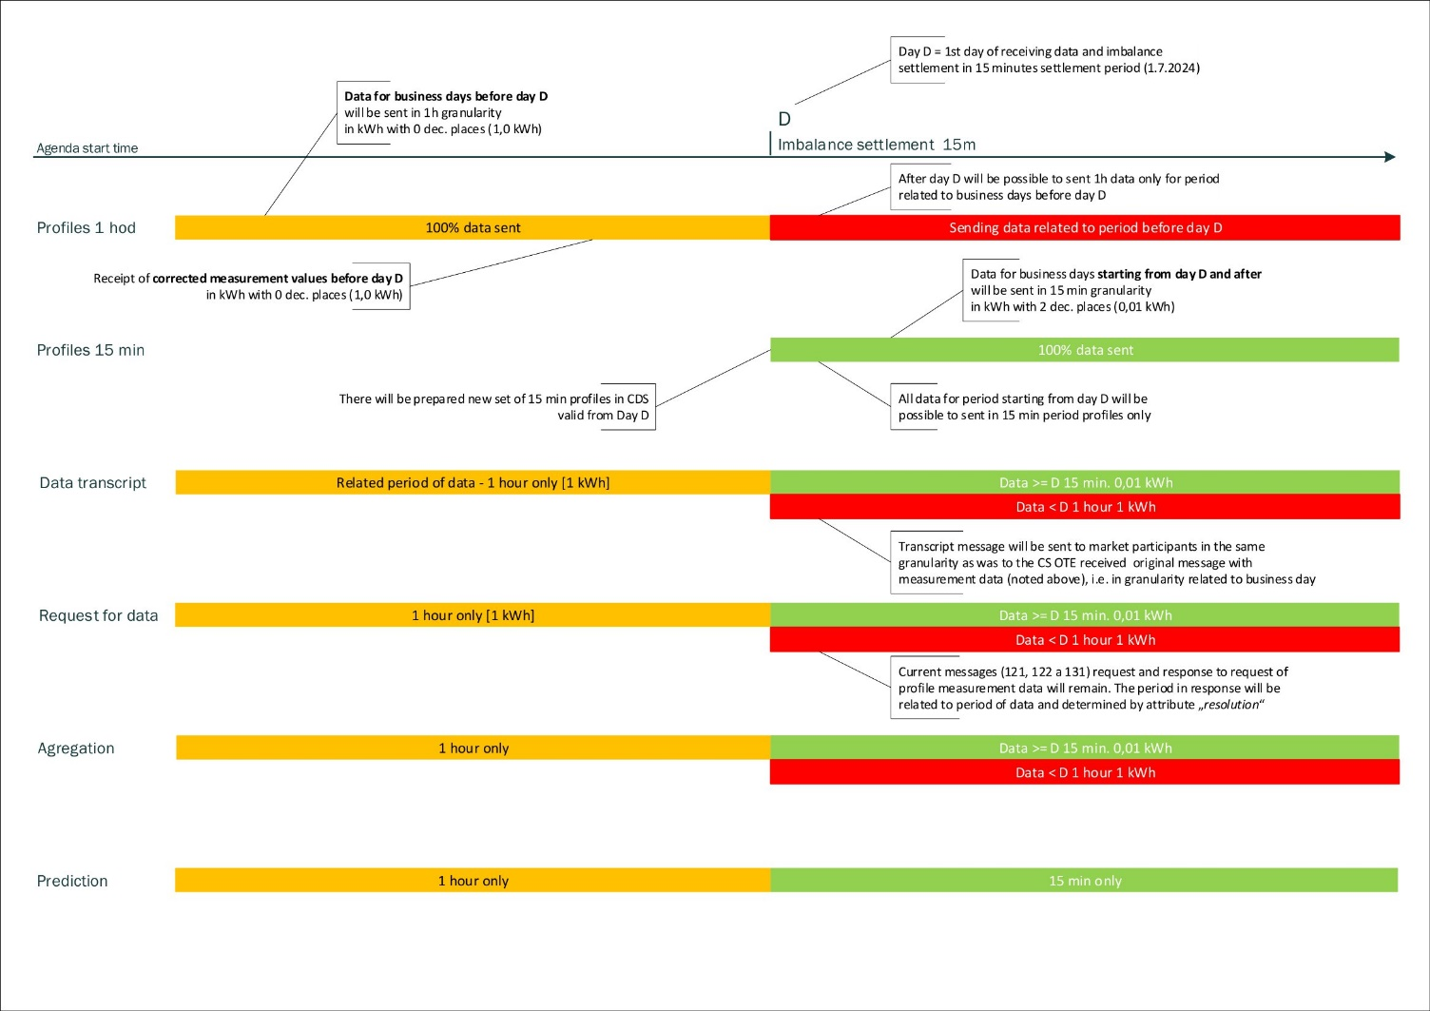

**Principles of transmission of measurement data:**

* + **Day D = 1st day of evaluation of deviations in 15-min. settlement interval (we assume 1.7.2024)**
    - Data for the evaluation intervals before D-day will be sent in 1h granularity with a resolution of the whole kWh.
    - Data for evaluation intervals starting from day D onwards will be sent in a granularity of 15 min with a resolution of 0.01 kWh.
    - In CDS OTE, 15-minute profiles will be prepared for D-day.
    - Receipt of correction measurement values for data before D-day will be in the granularity of 1h per whole kWh. This is due to the fact that in the case of sending back data in a granularity of 15 min, there may be a loss of resolution when calculating MV and ZMV deviations.
    - The report with the description of the measured data of individual PDTs will be sent to market participants in the same granularity as the report with the measurement data (see above) was received in CS OTE, i.e. in the format in which deviations are calculated.
    - The existing messages (121, 122 and 131) for query and response to query profile data over a 1 hour period will be retained - the granularity of the data will be determined by the resolution attribute.
    - Messages with identical message codes (121, 122 and 131) will be used for sending measurement data, data descriptions, queries for profile measurement data within a period of 15 minutes - the granularity of the data will be determined by the resolution attribute.
  + **Starting on day D-x (to be specified), it will be possible to receive contract values on delivery day D and at a granularity of 15 minutes.**
  + **Calculation and settlement of deviations**
    - DV calculated on day D for day D-1 at a granularity of 1h
    - DV calculated on day D+1 for day D at a granularity of 15 min
    - MV and ZMV calculated for the period before D-day will be performed at a granularity of 1h
    - MV and ZMV calculated for the period from day D onwards will be performed at a granularity of 15 min

**My understanding is that there will be no backward compatibility of the CDSDATA message. Corrections to the past in the new format, is that right?**

* + It will be possible to send a corrected CDSDATA message in the new format (using the new attributes) even if the original message was sent in the previous format.
  + If the sender wants to correct data sent in 60 min granularity, he must also send the message in 60 min granularity. This will also apply to corrections sent after the D change date (the date of the change of the billing period).

**Please comment on the impact on LP of introducing a 15-minute deviation clearing period. For example, a case where an annual meter reading (meter type C) will have part of the billing period falling within the 60-minute period and the rest within the 15-minute period. How will OTE take this into account?**

* + As regards the treatment of the PD metering reading with C metering, where part of the settlement period will fall within the 60-minute period and the rest within the 15-minute period, the deviation on the PDT will be calculated as the difference between the reading (consumption) of the PDT in question and the sum of the corrected estimates of the consumption of the PDT that entered the deviation settlement for the cleared consumption period. Thus, from a clearing perspective, it is the difference between two totals for a period, independent of the length of the clearing period.

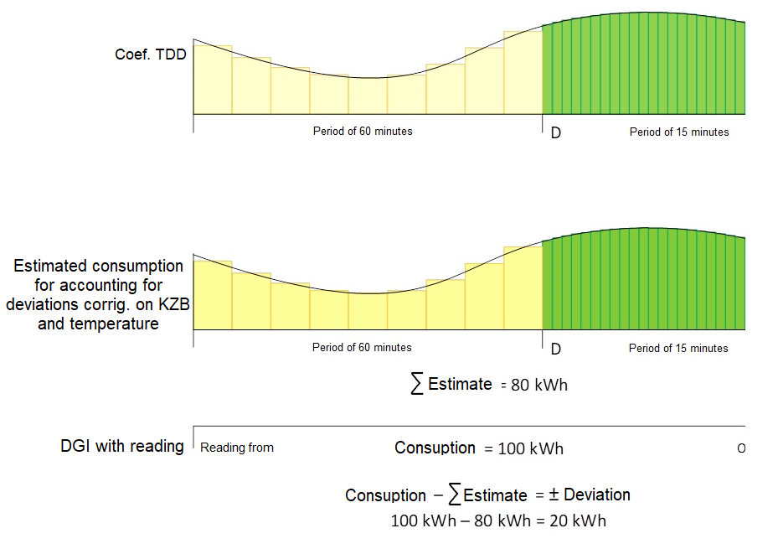

**Will the change in the accounting period have any overlaps with the POZE?**

**The moment the measured data and the daily market data are in 15min granularity, will the calculation of the compensation that OTE sends to the mandatory purchaser also be in 15min?**

* Even if there is a transition to a period of 15 minutes, it will be necessary to proceed according to the current legal regulations, which are Act No. 165/2012 Coll. (POZE Act) and relevant decrees. Currently, this law does not include a period of 15 minutes. In the event of a transition to a 15-minute period at the level of the POZE Act, there will be a settlement with the compulsory purchaser at the level of 15 minutes.

**From the point of view of the billing of electricity consumption to end customers and sending the data of consumption to 2 decimal places, it occurs to me that the billing should also include this extension. In your opinion, should the invoice contain consumption in MWh to 5 decimal places?**

* + The structure of the DUF report containing additional data for invoicing already currently allows the transmission of measurement data with a resolution in kWh to 2 decimal places, we do not anticipate a change here.
  + The details of the invoice are defined by legislation, or by the "supplier-customer" contractual relationship.

**Why don't you tame the attribute datetime-from to dtf to optimize the size of the messages?**

* + The attribute name corresponds to the current valid CDSDATA structure and only content reduction occurs within the message. Changing the name of the attribute would mean more intervention in the format of the message.

**Will it be possible to send data to OTE also in a csv file, as before?**

* + Yes, we assume that the possibility to transfer data to CS OTE as well as in a CSV file will be preserved.

**In the case of entering an offer on the daily market, the possibility to enter offers en masse (similar to a basket on VDT) within one data message. What happens if one or more offers submitted in one message are rejected (due to financial security)?**

* + Mass bidding is a planned conceptual functional change of DM not directly related to the 15-minute settlement period. In the current concept of the proposed change, offers provided within one data message, which do not represent linked block offers, will be processed independently, i.e. one or more rejected offers due to e.g. insufficient financial security will not affect the receipt of offers that successfully pass validation.

**The ability to enter linked block bids at once within one data message so that if one or more of the linked block bids fail to be processed, all linked block bids will be rejected by the system. What happens if one or more bids submitted in one message are rejected (due to financial security)?**

* + In the current conception of the draft of this conceptual change DM, linked block offers entered within one data message will either be accepted all or none, i.e. if at least one bid is not valid, all block bids from the given linked group of block bids will be rejected.

*Note: DV-* *daily evaluation of deviations, MV – monthly evaluation of deviations,   
ZMV – final monthly evaluation of deviations*

1. Used only within response to order data request for historical orders which used this discontinued attribute; cannot be used for order entry request.