USER ACCOUNTS MANAGAMENT MANUAL
Log into OTE system (CS OTE) to proceed the below mentioned actions. Link: https://portal.ote-cr.cz/.
- OTE SYSTEM USERS’ OVERVIEW
- HOW TO ADD A NEW USER
- HOW TO EDIT USER'S CONTACT INFORMATION
- ACTIVITIES ACCORDING TO THE TYPE OF CONTRACT
- HOW TO EDIT USER'S RIGHTS IN CS OTE
- HOW TO ADD ROLE FOR IM-BalM LIMIT SETUP
- HOW TO UPLOAD / DELETE CERTIFICATES
- HOW TO DELETE USERS

1. OTE SYSTEM USERS’ OVERVIEW

Users’ overview gives you the information about all the users registered by a particular company.

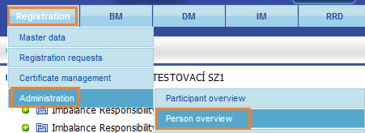

Authorized person which has the rights to users’ account management has attribute “Yes” in column “Role person registration“.

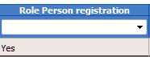

You can filter the list by:
“USER ID “ – user identification number;
“First name“;
“Surname“;
“Status“ – lists all the users or active or passive only;
“Certificate validity“ – lists all, valid or expired certificates.
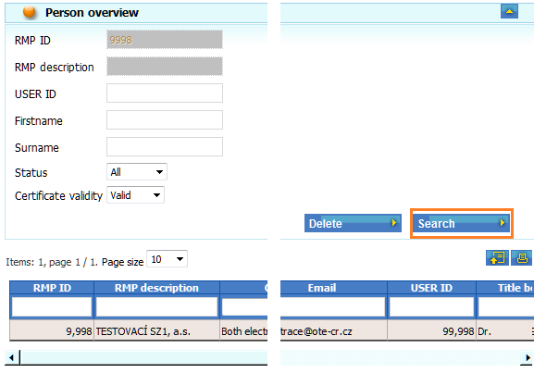

2. HOW TO ADD A NEW USER Back to content

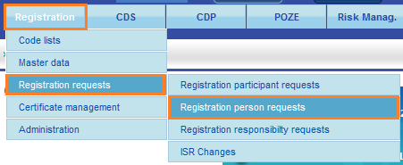

Go to “Registration person requests“, and click on the icon “N – new” in the top right corner.

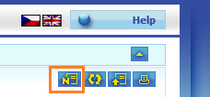
Part 1. Person identification – fill out at least the mandatory fields, which are marked with a star (*).
Part 3. Area of communication – fields “WRITE/READ“ will be opened up according to your agreements with OTE.
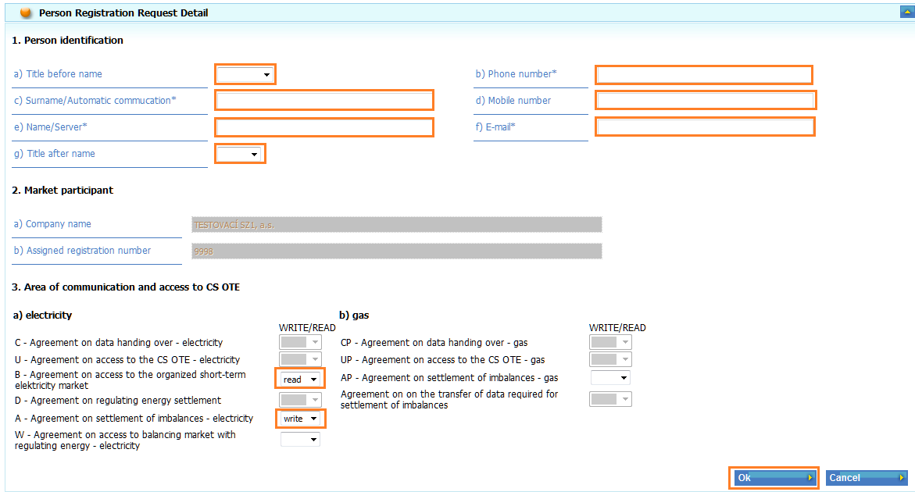
After choosing the desired rights click on the “OK” button and sign the request with your certificate.

1. 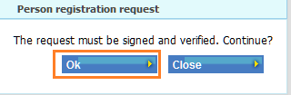 2. 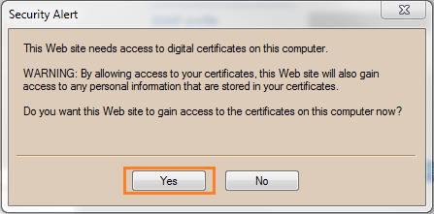
3. 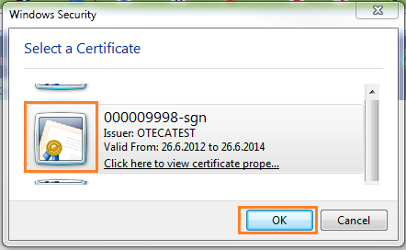 4. 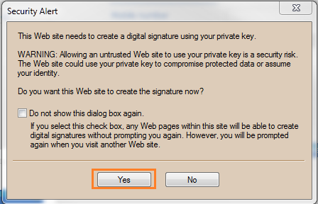
As soon as your request has been processed in CS OTE you will receive a confirmation email about the user registration.
To finish the registration upload his/her certificate according to the chapter HOW TO UPLOAD / DELETE CERTIFICÁTES.

3. HOW TO EDIT USER'S CONTACT INFORMATION Back to content

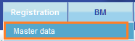
Go to “Master data“, click on “+“ at “Persons“ and on the user's name whose data you are going to edit.

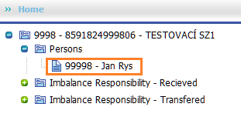
You can edit users' identification data and set POZE messages (information for the producers) in “Contact data”.
To set
– not encrypted POZE messages click “POZE messages “ and “Message format“ set to TXT (text message);
– encrypted messages click “POZE messages “ and “Message format“ set to XML.
Note: if you are OTE's contractual partner (trader, distributor) contact HelpDesk Electro, Market or Gas: 296 579 167, 173, 200 to set POZE messages.
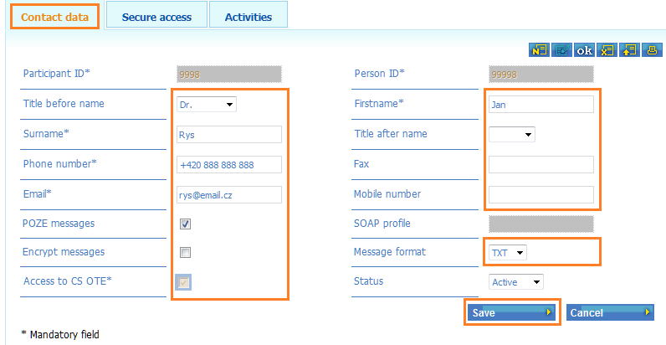
Click on the “Save“ button, and sign the data with your certificate.
1. 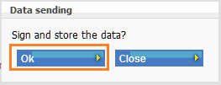 2.
3. 4.

4. ACTIVITIES ACCORDING TO THE TYPE OF CONTRACT Back to content
Relevant activities by user accounts according to the type of contract:
4.1. ELECTRICITY
A – Agreement on Settlement of Imbalances
Activities in CSOTE | Master data, user and certificate lists | Own certificate manage-ment | Access to CDS (measured data, change of supplier) | Financial reports | Settlement reports | Bilateral contracts (realisation diagrams record, reports) | Imbalance transfer to another BRP | Claims
Settlement of imbalances – electricity | X |  | X | X | X
Access on RRD – electricity | X |  |  | X | X | X
Claims | X | X | X |  |  |  |  | X
Handover deviation responsibility registration |  |  |  |  |  |  | X
B - Agreement on Access to the Organized Short-Term Electricity Market
Activities in CSOTE | Master data, user and certificate lists | Access to Day-Ahead Market screen | Access to Block Market screen | Access to Intra–Day Market screen | Financial reports | Settlement reports
Day-ahead Market | X | X |  |  | X | X
Block market – electricity | X |  | X |  | X | X
Access on IM market – electricity | X |  |  | X | X | X

C – Agreement on data handing over
Activities in CSOTE | Master data, user and certificate lists | Own certificate management | Access to CDS (measured data, change of supplier) | Claims | Access for DSO/TSO to Renewables
Metering data provider – electricity | X |  | X |  | X
Claims | X | X | X | X
D – Agreement on balancing energy settlement
Activities in CSOTE | Master data, user and certificate lists | Own certificate management | Financial reports | Settlement reports | Claims
RE provider | X |  | X | X
Claims | X | X |  |  | X
U – Agreement on access to CS OTE
Activities in CSOTE | Master data, user and certificate lists | Own certificate management | Access to CDS (measured data, change of supplier) | Claims | Bilateral contracts (realisation diagrams record, reports)
Centre of Data Services | X |  | X
Claims | X | X | X | X
Access on RRD – electricity | X |  |  |  | X
W – Agreement on Access to Balancing Energy Market
Activities in CSOTE | Master data, user and certificate lists | Own certificate management | Access to Balancing Energy Market screen | Financial reports | Settlement reports | Claims
Access on BalM market – electricity | X |  | X | X | X
RE provider |  |  |  | X | X
Claims | X | X |  |  |  | X

4.2. GAS
AP – Agreement on Settlement of Imbalances
Activities in CSOTE | Master data, user and certificate lists | Own certificate manage-ment | Nominations | Access to CDS (measured data, change of supplier) | Access to Day-Ahead Market screen | Access to Intra–Day Market screen | Financial reports | Settlement reports | Imbalance transfer to another BRP | Claims
Settlement subject - Gas | X |  | X | X | X |  | X | X
Claims | X | X |  | X |  | X |  |  |  | X
DM - Gas |  |  |  |  | X |  | X | X
IM - Gas |  |  |  |  |  | X | X | X
Handover deviation responsibility registration |  |  |  |  |  |  |  |  | X

CP – Agreement on data handing over
Activities in CSOTE | Master data, user and certificate lists | Own certificate management | Access to CDS (measured data, change of supplier) | Claims | Access for DSO/TSO to Renewables
Distribution system operator - Gas | X |  | X |  | X
Claims | X | X | X | X
UP – Agreement on access to CS OTE
Activities in CSOTE | Master data, user and certificate lists | Own certificate management | Access to CDS (measured data, change of supplier) | Claims
Metering data access - Gas | X |  | X
Claims | X | X | X | X

5. HOW TO EDIT USER'S RIGHTS IN CS OTE Back to content

Go to “Master data“ click on “+“ at “Persons“ and then click on the user's name whose data you are going to edit.

Choose “Activities“.

5.1. To add a new activity click on the icon “N- new” in the top right corner. Choose activity in the pop-up menu and for “Access” choose “W“ (writing) or “R“ (reading) and click on “Save“.

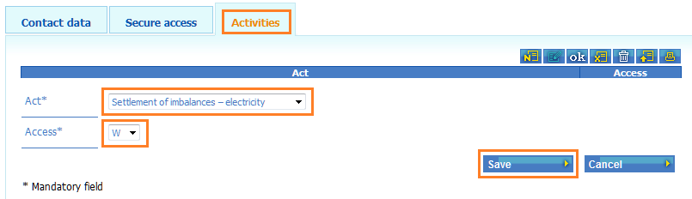
Sign your request with your certificate.
1. 2.
3. 4.
5.2. To change the access rights to an already existing activity click on the icon “writing mode“ in the top right corner which turns blue. Change the rights in “Access”, click on the “Save“ button, and sign with your certificate as in the step above.

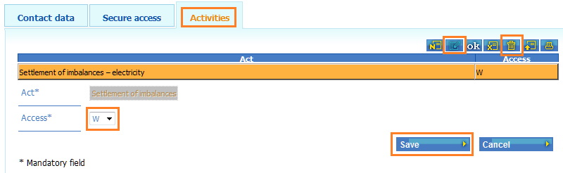
5.3. To take away an activity click on the icon “writing mode“ in the top right corner which turns blue. Mark the desired activity to delete and click on the icon “container“ , and you will be asked to confirm the change.

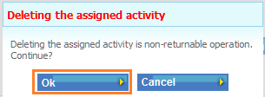

After hitting the “OK“ button the activity will be deleted. You do not sign this action.

6. HOW TO ADD ROLE FOR IM-BalM LIMIT SETUP Back to content
Go to “Master data“ click on “+“ at “Persons“ and then click on the user's name whose data you are going to edit.

Choose “Activities“.

6.1. Precondition for adding the role “Nastavení VDT/VT limitu / Setting IM-BalM limit” is that the user has at least one of the activities “Access on IM market – electricity” or “Access on BalM market – electricity” setup.
Choose “Roles“. Click on the icon “writing mode“ in the top right corner which turns blue. Click on “Assigned” and then click on “Save“.
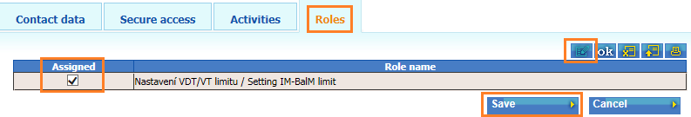
Sign your request with your certificate.
1. 2.
3. 4.

7. HOW TO UPLOAD / DELETE CERTIFICATES Back to content

Go to “Master data“ click on “+“ at “Persons“ and on the user's name whose data you are going to edit.

Choose “Secure access“.

7.1. Certificate upload
To upload a certificate click on the “N – new” icon in the top right corner. Click on “Procházet“ choose certificate to add into the fields “Autentication“ and “Signing“, click on the “Upload certificates“ button. At his moment the file paths disappear.
Then click the “Save“ button and sign the data with your certificate.

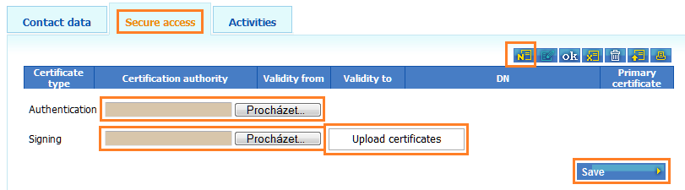
Note: you can use the same certificate for both authentication and signing. If you use two different certificates you will have to log in with the authentication certificate and sign the data with the signing certificate.
1. 2.
3. 4.
After the upload has finished the certificate detail will be displayed.

7.2. Certificate deletion
To delete certificate click on the icon “writing mode“ in the top right corner which turns blue. Mark the desired certificate to delete and click on the “Delete” button and sign the change with your certificate as in the step above.
Note: Each certificate will automatically be deleted 7 days after the expiry date.

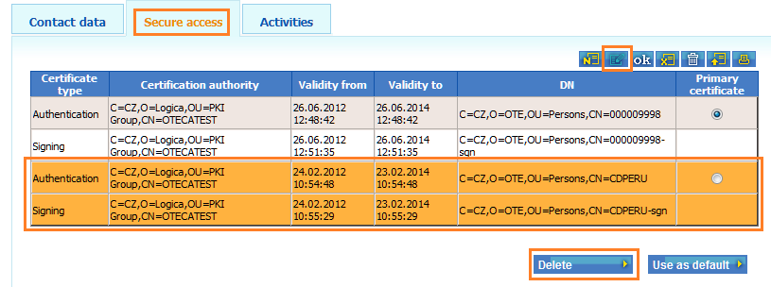
To change the primary certificate setting click on ”primary certificate” and then hit the “Use as default” button, and sign with your certificate.
Note: The option „primary certificate“ is relevant only for the automatic communication.

8. HOW TO DELETE USERS Back to content

Go to “Master data“ click on “+“ at “Persons“ and on the user's name whose account you are going to cancel.

Choose the Status “Inactive” in “Contact data”, and click on the “Save” button.
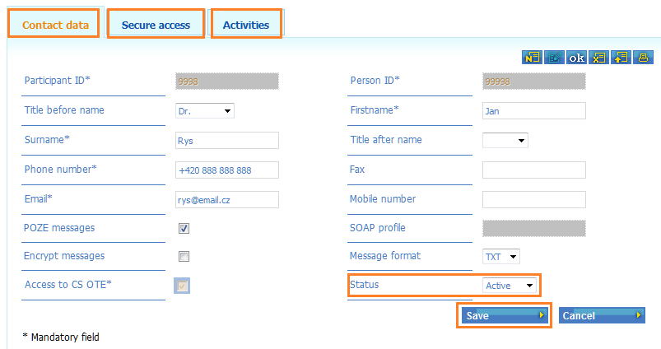

Sign the change with your certificate.
1. 2.
3. 4.

After confirmation you will be asked to delete all the certificates. Confirm by clicking “OK”.

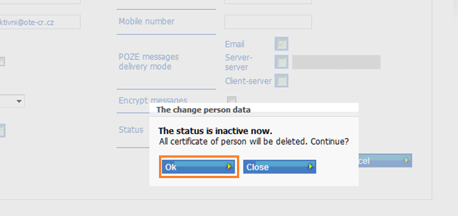
(Note: The status change is not sufficient for user deletion, it is necessary to delete certificate.

In “Secure access” check that all the certificates were deleted. By changing the status to “Inactive” the listing of the deactivated user in “Contact data” will be suppressed after the website refresh (F5).

“Registration -> Master data -> Persons“ displays only users with the status “Active“.
To check all the users (active/inactive) use OTE SYSTEM USERS’ OVERVIEW.

Back to content

