IBALANCE TRANFER MANUAL
Log into OTE system (CS OTE) to proceed the below mentioned actions. Link: https://portal.ote-cr.cz/.
- SETTING OF RIGHTS
- WHOLE IMBALANCE RESPONSIBILITY TRANSFER – request
- RESPONSIBILITY TRANSFER FOR RD, REGULATION ENERGY AND BALANCING MARKET– request
- IMBALANCE TRANFER / RESPONSIBILITY TRANSFER – confirmation from a BRP

SETTING OF RIGHTS

User who will send the responsibility transfer request has to have set the activity “Handover deviation responsibility registration” for reading “W”. See the chapter HOW TO EDIT USER'S RIGHTS IN CS OTE.

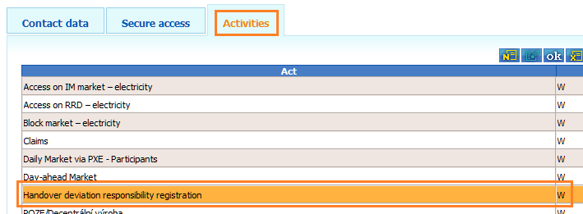

WHOLE IMBALANCE RESPONSIBILITY TRANSFER – request Back to the content

Whole imbalance transfer from one Balance Responsible Party (BRP) to another.

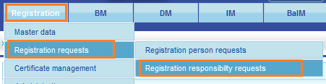
Go to „Registration responsibility request“, and click on the icon “N – new” in the top right corner.

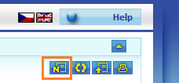

Note: If “Clearing for SuperSS” is not allowed the handing over BRP has to secure the financial security for clearing.

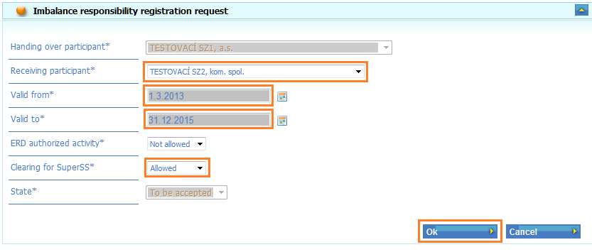

IMBALANCE RESPONSIBILITY TRANSFER – request Back to the content

Imbalance responsibility for Realization Diagrams, Regulation Energy and Accessing the Balancing Market if the trader is not a BRP.

Go to „Registration responsibility request“, and click on the icon “N – new” in the top right corner.

Note: To secure the access to the Balancing Market fill out only the “Receiving participant” and “validity”.

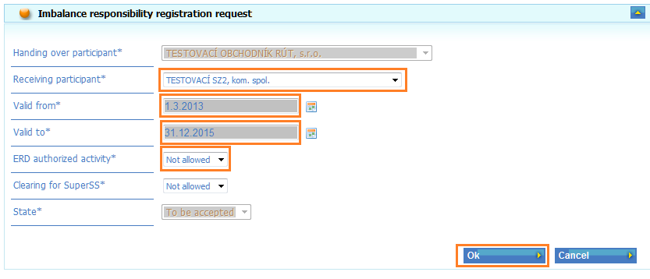
Fill out the required fields and click the “OK” button and sign with your certificate.
1. 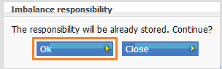 2. 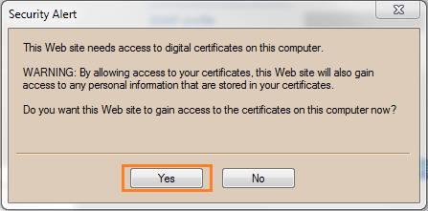
3. 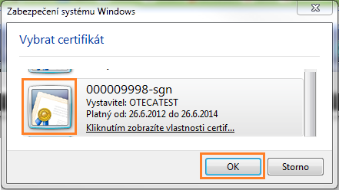 4. 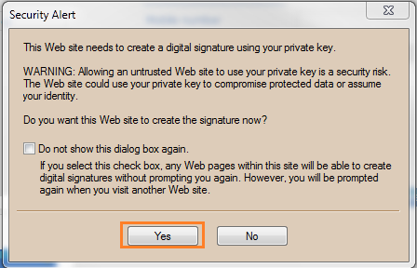

IMBALANCE TRANFER / RESPONSIBILITY TRANSFER – confirmation from a BRP Back to the content

Mark the request to confirm and click the “Edit” button.
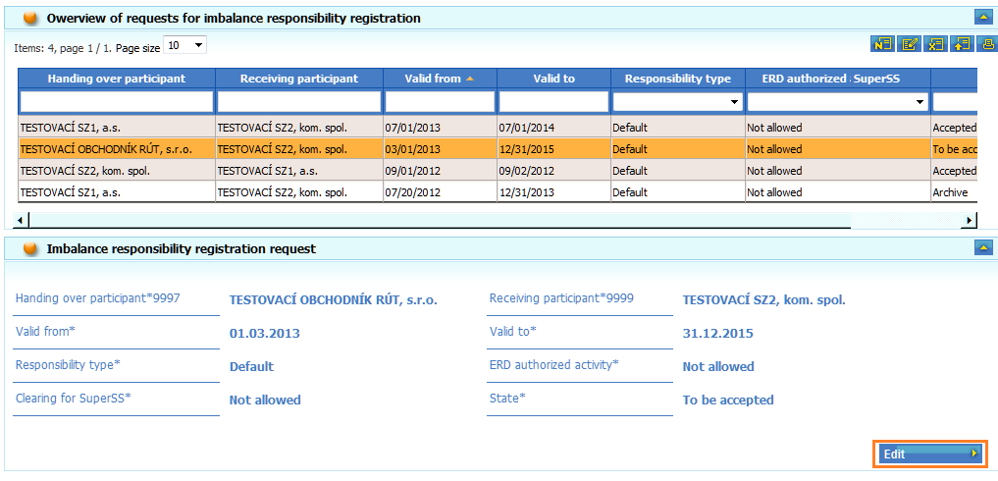
Choose state “FS checking” (financial security check), click “OK“, and sign with your certificate.
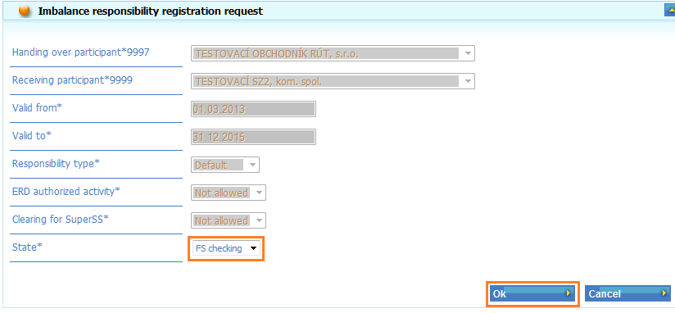
1. 2.
3. 4.
After a short period of time the state will automatically be changed to “Accepted”.

Back to the content

